

Team Around the School and Settings
School
Attendance
Toolkit

Contents

Introduction | Page 3
School Attendance Process Flow Chart | Page 4
Tier One (Pupils 100-93%) | Page 5
Suggested Strategies to Support Attendance | Page 6
Model Attendance Policy | Page 9
Attendance Recovery Individual Checklist | Page 26
Example Nudge Letter | Page 27
Monitoring Vulnerable Students Flow Chart | Page 28
Record of Contact | Page 29
Guide to First Day Calling | Page 31
Example Targeting Support Meeting Form | Page 35
Tier Two (Pupils 92-80%) | Page 38
Assess, Plan, Do, Review (APDR) | Page 39
Attendance Success Plan | Page 42
Additional Needs Plan | Page 50
Example Pupil Voice/Views | Page 60
Example Parent Views | Page 71
Tier Three (Pupils 79-51%) | Page 79
Attendance Support Plan | Page 80
Meeting Letter Invite | Page 90
Letter confirming meeting agreement | Page 91
Failed to Attend Meeting letter | Page 92
Formal Attendance Contract | Page 93
Formal warning letter for failing to secure improvements in school attendance | Page 99
Tier Four (Pupils below 50%)  Pathway to supportive services (Level 2 EHKW) | Page 103
Level 2 EHKW referral criteria | Page 104
Statutory Interventions information and templates

Penalty Notices | Page 105
Legal Interventions (Attendance Contract) | Page 106
Key Guidance Documents

Children Missing Education | Page 107
Children Entertainment and Employment | Page 107
The Teaching and Learning Provision | Page 109
Elective Home Education (EHE) | Page 110
Flexible Schooling (flexi-school) | Page 112
Reduced Timetable Guidance | Page 128
Reflective Checklist for using reduced timetables | Page 134
Off-Rolling | Page 138
School Table of Responsibilities | Page 142
Anxiety and Emotional Based School Avoidance (EBSA) | Page 143
Behaviour and Therapeutic Thinking | Page 144
Current School Offers | Page 145
Additional Resources and Information

WTTISA removing barriers to support attendance | Page 147
Whole School Attendance and Reflection Tool (EEF) | Page 148
Attendance Support, Advice and Guidance Line | Page 150
DfE Approved School Attendance Codes  With explanation on when and how to use | Page 151
Useful links | Page 166

Your attendance matters and so do you

Introduction
Welcome to the East Sussex County Councils, School Attendance Toolkit.
This toolkit has been designed in conjunction with the requirements of the

Working together to improve school attendance (applies from 19 August 2024) (publishing.service.gov.uk), to support you to meet the mandatory requirements set out in this statute, to outline the support that the Local Authority can offer, and to give you tools to use to support pupils when attendance becomes a concern.
All schools should have an attendance policy, that is easily accessible, and is regularly reviewed and updated, this will be a point of reference that you can share with parent/carers and will ensure consistency throughout the school. A model policy is included in this document which you can use/adapt to fit your school’s needs.
Early intervention is key to reducing severely and persistently absent rates, and there are certain forms and documents that will be required should you need to make a referral for support from a service outside of your setting. These are all within this document for your ease.
Throughout this document you will find links that you can click on, these will either take you to the appropriate web page, or page in the document. The Attendance Contract should not be adjusted, as this has been written to meet legislative requirements, but all other documents can be adapted to suit school and individual needs if required.
Where all voluntary support options are unsuccessful or are not appropriate (e.g. an unauthorised holiday in term time), the local authority’s school Attendance Support Team should liaise with school and the early help lead practitioner or social worker (where applicable) to take forward attendance legal intervention to formalise support and/or enforce attendance if appropriate.
Each School and Setting will have a nominated Single Point of Contact (SPOC) that will be your designated contact for support, you can also access the Attendance Support Advice Line, which operates daily during term time, between 10am and 3pm on 01273 481967.

School Attendance Processes
SCHOOLS : monitoring and tracking of attendance at whole school level.

Named SPOC will hold attendance Targeting Support Meeting to discuss trends, systems, data and emerging school needs, including pupil cohorts and individual pupils and link to EEF blue one)
Actions identified – school/AST SPOC/ signposting for support.

Tier 1: 100% - 93%
Schools monitor, track and implement early intervention strategies including recognising improved attendance.
The DfE have a set of steps to support.
Tier 4: 50% ≥
Early Help Keywork– 12 – 20-week intervention
All referral criteria must be met prior to a referral being made via SPOA Portal using the SOR form.
If a referral is declined, information, advice and guidance will be provided to the referring school and parents from Level 2 Early Help. For cases accepted, an Early Help Plan will be developed with family and school. Support will be reviewed at end of a 10-week period. The aim of the intensive support is to gain sustained change and improvement.
At the closing meeting with the Level 2 keyworker, school to re-open the attendance support plan and continue to monitor and support improvements to attendance.
Schools will retain responsibility to consider statutory interventions where appropriate and continue to seek advice and guidance from the attendance SPOC.

Tier 3: 79% - 51%
School and AST SPOC identify targeted groups and emerging needs.
Time-limited targeted group work can be discussed with attendance SPOC and undertaken by an AST practitioner.
School to continue to hold reviews, implement supportive interventions and evidence strategies in existing plans.
Where all supportive measures have been exhausted, a formal attendance contract may be considered at this stage. Where there is no improvement and attendance remains a concern, school to consider next steps in discussion with the attendance SPOC, including a LA multi-agency response, the use of the penalty notice pathway, and if necessary, referrals to additional services, which may include statutory interventions.
School to consult attendance SPOC when legal interventions are being considered as the next step. A legal interventions referral form (LIP) will be provided to the school by the attendance SPOC. The attendance SPOC will be available to review the LIP referral form prior to submission to the LA.
Tier 2: 92% - 80%
Where complex or additional SEND needs are identified, school to embed support. School identifies cohorts for in-school group support/mentoring support/parent-school meetings. Additional support if required can be sought through the school’s attendance SPOC.
School completes an Assess Plan Do Review form and pupil voice for pupils or an attendance support plan with 92% and below attendance.
School to hold reviews, a minimum of every three weeks, to implement supportive interventions.
Where there is no improvement and attendance remains a concern, school to consider next steps, including the use of the penalty notice pathway, if appropriate and referrals to additional services, if necessary.
School Action
AST
Action
AST Targeted cohort support/Advice and Guidance

AST SPOC will be available to attend and support with advice and guidance CIN/CP/YJS/CLA multi-agency meetings where attendance is a cause for concern.
Attendance Targeting Support Meetings will be scheduled as appropriate.
SPOC available for advice/guidance/ training support to staff. Daily Attendance Helpline is available.

Tier One
When attendance drops, it is imperative that schools act quickly and intervene early to identify root causes and barriers and work jointly with the pupil and their family to support them to do this.
Having robust structures and procedures in place for monitoring and recording absences on the first day, (first day calling) is a necessity to identify themes and patterns and be able to support at an early stage. First day calling should also include a protocol for supporting the pupils in your vulnerable cohorts.
Contacting home will be key in building a relationship with the young person’s family, but it is important that you record this as it will form evidence should there not be an improvement. You could use a template to do this on, or your schools management information systems.
You need to gain the views of both the parent and pupil, and could also use a checklist to talk to the pupil about factors that they may feel are barriers, and use the suggested strategies to look at ways to remove barriers, or for older pupils ask them to consider how they can help themselves to improve their attendance and barriers that they feel are preventing them from attending regularly.
Some parents may respond to communication that is more informal, and outlines that their child/young person is missing out by not being in school. You could consider something like a nudge letter to do this.
Attainment is directly linked to attendance, and it’s important to build good habits from an early age, that can continue throughout the pupil’s academic journey and into adulthood.

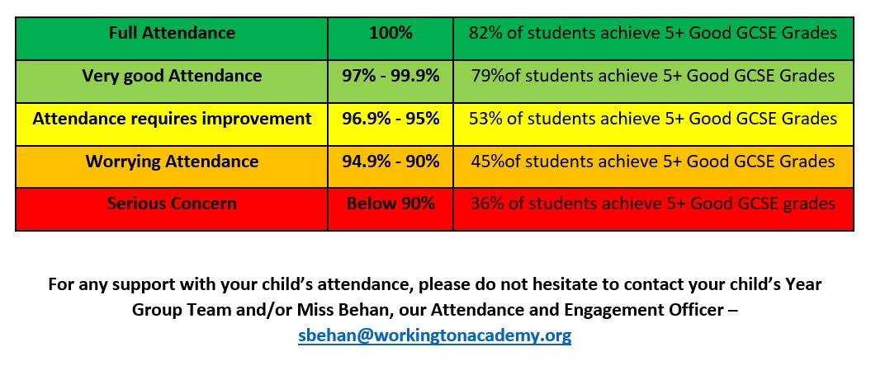
These suggested strategies are in line with the expectations of the new DfE guidance
‘Working Together to Improve School Attendance’

Safeguarding and Attendance is everybody’s responsibility.

Early Intervention Strategies or Green Level Strategies  Early intervention could remove or resolve barriers and prevent escalation of need and drop in attendance. This will enable the child or young person to continue to attend school with the right and timely support in place | Tick if used
Robust attendance monitoring systems and reporting of concerns

Try to identify issues as early as possible. Are there any patterns or barriers?
It is the role of the attendance officer/designated staff to communicate information gathered with key pastoral staff, the SEND team, DSL if appropriate or attendance leads

Attendance and absence communication - verbal and written

Use of red/amber/ green letters/ nudge letters / schools’ own attendance awareness letters, phone calls, virtual chats, and other forms of messaging to ensure parents/carers have received the communications in a format that is understandable and actionable

Meeting and gathering parent/carer voice

What do the parents perceive as the barriers to regular attendance, and how can this be jointly addressed?
Build positive relationships with families and young person. Listening to their story will enable a trust to be formed.
Undertake home visits for non-attendance at meetings to gain a full picture, offer virtual and phone meetings if parent/carer unable to attend in person.
Set dates to review the supportive strategies at least fortnightly and monitor progress within a 6-week period as a minimum

Gaining pupil voice

When gaining pupil voice points to consider:
What are the young person’s views on barriers to attendance?
What support can be put in place to ensure full engagement in learning and school?
What would make a difference? What does the young person consider as their strengths/likes and dislikes?
What attempts have you made to complete the pupil voice?
Has a home visit been undertaken where there has been no engagement or an offer of meeting in an alternative safe location been considered if the pupil has not engaged in this activity?
Has progress made been reviewed with the pupil?

School Health Service

Find out about any medical conditions and the reasonable adjustments that might be necessary. Refer to the school health service, or with permission ask the school nurse to contact the consultant involved for more specific information.
Implement an Individual Health Care plan if appropriate with clear targets and reviews.
Risk Assessment

Is a risk assessment or safety plan necessary? Is it up to date?

Assess Plan Do Review

Start an Assess Plan Do Review document, set clear SMART goals, ensure that these are reviewed, and new actions identified.

Reasonable Adjustments

An adapted timetable that can be ragged (red,amber,green) with the pupil
Flexible use of the classroom
Seating and classroom layout planned to meet needs of individual student (medical, social, emotional). Young person has been part of the planning for this.
Buddy system
To support social and emotional development opportunities.
Use of medical room (if appropriate)
Do they know where this is and have, they been introduced to the first aiders?
Identified trusted adults and peer grouping
Can you reduce the number of staff working with the student? Choose staff members and students who work well with the young person.
Modified plan for PE and outdoor play (if appropriate)
Adaptation policies to meet personal needs of a student e.g. uniform adjustments for students with sensory needs.
EBSA Guidance and Toolkit (CZONE)
A support plan/APDR/ANP to record and review any reasonable adjustments made or offered
School Mental Health Practitioner Support

Assessment of other learning needs

Consider any unmet/undiagnosed needs that may impact on attendance and steps that can be taken to support, including referrals to ISEND support services

Advice and Guidance

The Team around the School and Setting (TASS) Attendance Helpline is available between 10am and 3pm daily on 01273 481967

Targeted support strategies or Amber level strategies  Absence issues have escalated, and concerns remain despite early intervention support. Further additional measures can be facilitated that may engage the pupil and or parents/carers, including formalising support through a formal plan with targets to be reviewed in a timely manner | Tick if used
Trusted Adult (s)

A named adult who the student can check-in with. Ideally a member of staff in the school who the child has identified as having a positive relationship with (this might be the librarian or receptionist – it doesn’t have to be a teacher)

Use of a safe place for learning

Can the young person temporarily complete their work in an alternative location within school? Is there an office or meeting room where they feel safe?

Adapted Timetable / Day

Needs to be planned carefully and tailored to match young person’s needs at that time.
Student can RAG timetable and attend green lessons, later starts if poor sleep patterns are an issue, going home for lunch if issues are at unstructured times, reducing option subjects, arranging other provisions (e.g. work experience, Albion in the Community, Plumpton College, Duke of Edinburgh). Be creative. Review regularly.
Is a later start/ earlier finish appropriate as a short-term measure to build resilience?
Use the ESCC reduced timetable guidance if you adjust the school day for any young people.

Intervention programmes

E.g. Anxiety and resilience building programmes such as Worry Busters, Molehill Mountain, Therapeutic Thinking Anxiety Tool Analysis
Exam stress intervention groups
Social skills groups
Nurture groups
Thrive programme/ Boxall profile
Therapeutic thinking model and language is used
If learning needs are identified, these are targeted through appropriate intervention.

Advice from specialists, multi-agency collaboration, may need to make a referral

E.g. CAMHS (Child and Mental Health Service), CITES (Children’s Integrated Therapy Service for physical, occupational or speech and language difficulties), Service for Children with Sensory Needs, Access and Disability Service, Early Years’ Service, Early Help Key Worker Services (Emotional well-being Team), SPOA (Single Point of Advice), School Health Team, School Mental Health Support Practitioner

Counselling Services

In school or outside of school services

Parenting

Signpost parent to the ESCC local offer, refer to parenting support such as ‘Open for Parents’, complete a parenting contract, and gain parent views. Use parenting contract.

Specialist equipment

Is this needed to support attendance? Who can provide this?

Formalising attendance Improvement

Consider the Attendance Improvement Agreement or equivalent prior to considering the Fixed Penalty Notice procedure. Are referrals needed for alternative/additional support i.e. Early help Keywork, CLASS+, Spectrum, IROCK, Emotional Wellbeing and Mental Health Support Services

Specialist level strategies or Red level strategies  Where attendance is below 50%, there is evidence of suggested strategies being used/attempted, and there are complex needs. | Tick if used
Refer to the Level 2 keywork service may be considered

School name/logo

PUPIL
ATTENDANCE
POLICY

The name and contact details of the Senior Attendance Champion – the senior leader responsible for the strategic approach to attendance in our school, is:
Name
Email address or contact details
AMEND ACCORDINGLY

The name and contact details of the school staff member pupils and parents should contact about attendance on a day-to-day basis is:
Name
Email address or contact details
AMEND ACCORDINGLY

The name and contact details of the school staff member pupils and parents should contact for more individual support with attendance (Attendance Officer/Pastoral Support Worker/Head of Year etc):
Name
Email address or contact details

The name of our linked Governor with responsibility for monitoring attendance is:
NON- STATUTORY – INCLUDE IF APPLICABLE

Staff consulted:

Ratified by the Governing Body:

Review Date: Annual review

XX School/Academy

Pupil Attendance Policy

Introduction and Background

XX School/Academy recognises that positive behaviour and good attendance are essential in order for pupils to get the most of their school experience, including their attainment, wellbeing and wider life chances.

The law entitles every child of compulsory school age to an efficient, full-time education suitable to their age, aptitude, and any special educational need they may have. It is the legal responsibility of every parent to make sure their child receives that education either by attendance at a school or by education otherwise than at a school.

Where parents decide to have their child registered at school, they have an additional legal duty to ensure their child attends that school regularly, on time. This means their child must attend every day that the school is open, except in a small number of allowable circumstances such as being too ill to attend or being given permission for an absence in advance from the school.

The Department for Education (DfE) has produced statutory guidance for maintained schools, academies, independent schools, and local authorities. It is called “Working together to improve school attendance” and it includes a National Framework in relation to absence and the use of legal sanctions. Our School Attendance Policy reflects the requirements and principles of that guidance.

This policy is written with the above guidance in mind and underpins our school ethos to:
- promote children’s welfare and safeguarding;
- ensure every pupil has access to the full-time education to which they are entitled;
- ensure that pupils succeed whilst at school;
- ensure that pupils have access to the widest possible range of opportunities at school, and when they leave school.

It seeks to ensure that all stakeholders involved in the practicalities of school attendance are aware and informed of attendance matters in school and to outline the school’s commitment to attendance matters. It details the responsibilities of individuals and groups involved and the procedures in place to promote and monitor pupil attendance.

In addition, all schools follow the DfE’s statutory safeguarding guidance, Keeping Children Safe in Education, which emphasises the importance of understanding the potential vulnerabilities of children who are missing or absent from education.
https://www.gov.uk/government/publications/keeping-children-safe-in-education--2
Our policy aims to raise and maintain levels of attendance by:
- Promoting a positive and welcoming atmosphere in which pupils feel safe, secure and valued;
- Raising and maintaining a whole school awareness of the importance of good attendance and punctuality;
- Ensuring that attendance is monitored effectively and reasons for absences are recorded promptly and consistently.

For our children to gain the greatest benefit from their education it is vital that they attend regularly and be at school, on time, every day the school is open unless the reason for the absence is unavoidable. It is a rule of this school that pupils must attend every day, unless there are exceptional circumstances, and it is the Headteacher/principal, not the parent, who can authorise the absence.

Promoting Regular Attendance

At XXXX school, we believe in developing good patterns of attendance and set high expectations for the attendance and punctuality for all our pupils from the outset. It is a central part of our school’s vision, values, ethos and day to day life. We recognise the strong connections between attendance, attainment, safeguarding and wellbeing.

The name and contact details of the Senior Attendance Champion (the senior leader responsible for the strategic approach to attendance in our school) is:
Name
Email address or contact details
AMEND ACCORDINGLY

The governor with responsibility for monitoring attendance is AMEND ACCORDINGLY
[Not statutory, but recommended by the DfE guidance]

Helping to create a pattern of regular attendance is the responsibility of parents, pupils and all members of school staff.

To help us all to focus on this, we will:

- Submit a daily attendance return to the Department of Education, in line with the legal expectations placed on all schools;
- Build strong relationships and work jointly with families;
- Give parents/carers details on attendance in our newsletters;
- Promote the benefits of high attendance;
- Accurately complete admission and, with the exception of schools where all pupils are boarders, attendance registers and have effective day to day processes in place to follow-up absence as required by law;
- Celebrate excellent attendance by displaying and reporting individual and class achievements;
- Reward good or improving attendance;
- Add any additional ways in which you promote and incentivise school attendance.
- Report to parents/carers regularly on their child’s attendance and the impact on their progress;
- Contact parents/carers should their child’s attendance fall below the school’s target for attendance.

Understanding Types of Absence

Any absence affects the routine of a child’s schooling and regular absence will seriously affect their learning journey and ability to progress. Any pupil’s absence or late arrival disrupts teaching routines and so may affect the learning of others in the same class. Ensuring a child’s regular attendance at school is a parental responsibility and allowing absence from school, without a good reason, creates an offence in law and may result in prosecution.

Every half-day absence from school has to be classified by the school (not by the parent), as either authorised or unauthorised. This is why information about the cause of any absence is always required. Each half-day is known as a ‘session’.

Authorised absences are morning or afternoon sessions away from school for a genuine reason such as illness (although you may be asked to provide medical evidence for your child before this can be authorised), medical or dental appointments which unavoidably fall in school time, emergencies or other unavoidable cause.

Unauthorised absences are those which the school does not consider reasonable and for which no ‘leave’ has been granted. This type of absence can lead to the school referring to the Local Authority for penalty notices and/or legal proceedings.

Unauthorised absence includes, (however this list is not exhaustive):
- parents/carers keeping children off school unnecessarily e.g. because they had a late night or for non-infectious illness or injury that would not affect their ability to learn;
- absences which have never been properly explained;
- children who arrive at school after the close of registration are marked using a ‘U’. This indicates that they are in school for safeguarding purposes, however is counted as an absence for the session;
- shopping trips;
- looking after other children or children accompanying siblings or parents to medical appointments;
- their own or family birthdays;
- holidays taken during term time, not deemed ‘for exceptional purposes’ by the Headteacher, including any arranged by other family members or friends;
- day trips;
- other leave of absence in term time which has not been agreed.
Persistent Absenteeism (PA) and Severe Absenteeism (SA)

A pupil is defined by the Government as a ‘persistent absentee’ when they miss 10% or more schooling across the school year for any reason; this can be authorised or unauthorised absence. Absence at this level will cause considerable damage to any pupil’s education and we need the full support and co-operation of parents to resolve this. All pupils who have attendance levels of 90% or below are considered to be a persistent absentee.

A pupil who has missed 50% or more schooling is defined by the Government as ‘severely absent’. Pupils within this cohort may find it more difficult to be in school or face bigger barriers to their regular attendance and, as such, are likely to need more intensive support.

Absence Procedures

The name and contact details of the school staff member pupils and parents should contact about attendance on a day to day basis is:
Name
Email address or contact details
AMEND ACCORDINGLY

We monitor and review all pupils’ absence, and the reasons that are given, thoroughly.

If a child is absent from school the parent must follow these procedures:
- Contact the school on the first day of absence before 9.20 am, when our register closes;
- The school has an answer phone available to leave a message if nobody is available to take your call, or you may call into school personally and speak to the office staff. Please be aware that, if you leave a voicemail to report your child’s absence, you may receive a call from the school so that we may discuss the absence before making a decision as to whether the absence is to be recorded as authorised;
- Contact the school on every further day of absence, again before 9.20 am;
- Ensure that your child returns to school as soon as possible and you provide any medical evidence, if requested, to support the absence. Medical evidence may be requested where your child is having multiple periods of absence which are reported as being due to medical reasons. When determining whether a child is too ill to attend school, both parents and school staff can consider the advice contained within the NHS and East Sussex County Council Guidance on School Absence and Childhood Illness.

If your child is absent we will:
- Telephone or text you on the first, and every subsequent day of absence, if we have not heard from you. However, it is your responsibility to contact us;
- If we are unable to make contact with parents by telephone, we will telephone emergency contact numbers, send letters home and a home visit may be made, in the interests of safeguarding;
- A referral will be made to Local Authority if no contact has been made with parents by the 10th day of absence (or sooner if deemed appropriate), at which point your child will be considered to be “missing from education.”
If absence continues we will:
- Write to you if your child’s attendance is below 95% / causing concern AMEND WITH SCHOOL TARGET, and/or where punctuality is a concern;
- Arrange a meeting so that you may discuss the situation with our Senior Attendance Champion or AMEND ACCORDINGLY
- Create a personalised action/support plan, such as an attendance contract, to address any barriers to attendance and make clear each person’s role in improving the attendance patterns of your child;
- Offer signposting support to other agencies or services, if appropriate;
- Refer the matter to the Local Authority for relevant legal sanctions, if attendance deteriorates following the above actions.

Lateness

Poor punctuality is not acceptable and can sometimes lead to irregular school attendance patterns. Good time-keeping is a vital life skill which will help children as they progress through their school life and out into the wider world.

Pupils who arrive late disrupt lessons and, if a child misses the start of the day, they can feel unsettled and embarrassed and risk missing vital work and important messages from their class teacher.
The times of the start and close of the school day for all pupils at X School are:
Gates open: 8.40am
Registration starts: 8.45am
Registration closes: 9.00am
End of the school day: 3.20pm
AMEND ACCORDINGLY

How we manage lateness: AMEND AS APPROPRIATE
- The school day starts at 8.40am when children can begin to come into school;
- Registers are taken at 8.50am;
- Children arriving after 8.55am are required to come into school via the school office. If accompanied by a parent/carer they must sign them into our ‘Late Book’ and provide a reason for their lateness, which is recorded; KEEP/REMOVE IN LINE WITH SCHOOL’S OWN PRACTICES
- At 9.20am the registers will be closed. In accordance with the Regulations, if your child arrives after that time, they will receive a mark that shows them to be on site – ‘U’, but this will not count as a present mark and it will mean that they have an unauthorised absence;
- The school may contact parents/carers regarding punctuality concerns;
- From time to time a member of school staff will undertake a ‘Late Gate’ check, greeting late arrivals at the main entrance to the school.
Unauthorised lateness could result in the school referring to the Local Authority for sanctions and/or legal proceedings. If your child has a persistent lateness record, you may be asked to meet with XXXXX SPECIFY ALLOCATED STAFF MEMBER, but you can approach us at any time if you are having difficulties getting your child to school on time. We expect parents and staff to encourage good punctuality by being good role models to our children and, as a school, we celebrate good class and individual punctuality.

Understanding barriers to attendance

Whilst any child may occasionally have time off school because they are too unwell to attend, sometimes they can be reluctant to attend school. Any barriers preventing regular attendance are best resolved between the school, the parents and the child. If a parent thinks their child is reluctant to attend school, then we will work with that family to understand the root problem and provide any necessary support. We can use outside agencies to help with this, such as the School Nurse, Mental Health and Emotional Wellbeing support services, Early Help Key Worker team, a Family Support Worker or the relevant Local Authority team/s. Where outside agencies are supporting the family, you may be invited to attend a meeting to consider what is working well and what needs to improve. An individual support plan will be agreed and subsequently reviewed.

Some pupils face greater barriers to attendance than their peers. These can include pupils who suffer from long-term medical conditions or who have special educational needs and disabilities, or other vulnerabilities. High expectations of attendance remain in place for these pupils, however we will work with families and pupils to support improved attendance whilst being mindful of the additional barriers faced. We can discuss reasonable adjustments and additional support from external partners, where appropriate.

Under the DfE’s statutory guidance, schools are required to submit a sickness return to the Local Authority for all pupils who have missed/are likely to miss 15 or more school days (consecutive or cumulative) due to medical reasons/illness.

See Annex A for summary tables of responsibilities for school attendance.

The name and contact details of the school staff member pupils and parents should contact for more detailed support on attendance:
Name:
Email address or contact details:

Local Authority Attendance Support Team

Local Authority Attendance Support Team (AST) work strategically by offering support, advice and guidance to schools, to reduce persistent absence and improve overall attendance.

Parents are expected to work with the school and local authority to address any attendance concerns. Parents should proactively engage with the support offered, aiming to resolve any problems together. This is nearly always successful. If difficulties cannot be resolved in this way, the school may consider more formal support and/or refer the child to the Local Authority. If attendance does not improve, legal action may be taken in the form of a Penalty

Notice (see Annex B for the East Sussex Code of Conduct) or prosecution in the Magistrates Court.

School Attendance and the Law

New legislation was passed, The School Attendance (Pupil Registration) (England) Regulations 2024 which introduced a National Framework in England. By law all children of compulsory school age must receive an appropriate full-time education (Education Act 1996). Parents have a legal duty to ensure their child attends school regularly at the school at which they are registered.

Parents may be recognised differently under education law, than under family law. Section 576 of the Education Act 1996 states that a ‘parent’, in relation to a child or young person, includes any person who is not a parent (from which can be inferred ‘biological parent’) but who has parental responsibility, or who has care of the child.
A person typically has care of a child or young person if they are the person with whom the child lives, either full or part time and who looks after the child, irrespective of what their biological or legal relationship is with the child.

National Framework for Penalty Notices

There is now a single consistent national threshold for when a penalty notice must be considered by all schools in England, of 10 sessions (usually equivalent to 5 school days) of unauthorised absence within a rolling 10 school week period. The 10 sessions of absence do not have to be consecutive and can be made up of a combination of any type of unauthorised absence (G, O and/or U coded within the school’s registers). The 10 school week period can span different terms, school years or education settings.

Sanctions may include issuing each parent (for each child) with a Penalty Notice for £160, reduced to £80 if paid within 21 days (for the first offence). A second Penalty Notice issued within a three year period will result in a fine of £160 per parent, per child. If a third offence is committed the matter may be referred to the local authority for consideration of prosecution via the Magistrates Court. If prosecution is instigated for irregular school attendance, each parent may receive a fine of up to £2500 and/or up to 3 months in prison. If a parent is found guilty in court, they will receive a criminal conviction.

See Annex B for the East Sussex Code of Conduct.

There is no entitlement in law for pupils to take time off during the term to go on holiday or other absence for the purpose of leisure or recreation, or to take part in protest activity in school hours. In addition, the Supreme Court has ruled that the definition of regular school attendance is “in accordance with the rules prescribed by the school.”

The School Attendance (Pupil Registration) (England) Regulations 2024 set out the statutory requirements for schools. All references to family holidays and extended leave have been removed. The amendments specify that Headteachers may not grant any leave of absence during term time unless there are "exceptional circumstances" and they do not have any discretion to authorise up to ten days of absence each academic year.

It is a rule of this school that a leave of absence shall not be granted in term time unless there are reasons considered to be exceptional by the Headteacher, irrespective of the child’s overall attendance. Only the Headteacher or his/her designate (not the local authority) may authorise such a request and all applications for a leave of absence must be made in writing, in advance, on the prescribed form provided by the school. The school will usually consider that the parent who has made the application is therefore allowing the leave of absence, and also that all parents who are on the holiday are allowing the leave. Where a parent removes a child after their application for leave was refused or where no application was made to the school, the absence will be recorded as unauthorised. It is likely that penalty notices will be requested, in line with the National Framework and East Sussex Code of Conduct, in respect of each parent believed to have allowed the absence.

At X School/Academy 'exceptional circumstances' will be interpreted as:
... being of unique and significant emotional, educational or spiritual value to the child which outweighs the loss of teaching time (as determined by the Headteacher). The fundamental principles for defining ‘exceptional’ are events that are “rare, significant, unavoidable and short”. By 'unavoidable' we mean an event that could not reasonably be scheduled at another time, outside of school term time, regardless of who has planned or paid for the holiday or absence (including grandparents or other family or friends).

The Headteacher/school may discuss the leave of absence request with other education settings and/or the Local Authority to determine any exceptional circumstances.

If leave of absence is authorised, the school will not provide work for children to do during their absence. Parents are however advised to read with their children and encourage them to write a diary while they are away.

Deletion from Roll

For any pupil leaving XX Primary School, other than at the end of year 6/ leaving XX secondary school other than at the end of year 11, parents/carers are required to complete a ‘Pupils moving from school’ form which can be obtained from the school office. This provides school with the following information: Child’s name, class, current address, date of leaving, new home address, name of new school, address of new school. This information is essential to ensure that we know the whereabouts and may appropriately safeguard all of our pupils, even those who leave us.

It is crucial that parents keep school updated with current addresses and contact details for the pupil and key family members, in case of emergency.

Under Pupil Regulations 2006, all schools are now legally required to notify their Local Authority of every new entry to the admission register within five days of the pupil being enrolled. In addition to this, every deletion from the school register must also be notified to the Local Authority, as soon as the ground for deletion has been met in relation to that pupil, and in any event no later than the time at which the pupil’s name is deleted from the register. This duty does not apply when a pupil’s name is removed from the admission register at a standard transition point – when the pupil has completed the final year of education normally provided by that school.

Absence data

We use data to monitor, identify and support individual pupils or groups of pupils when their attendance needs to improve, and schools are required to submit pupil attendance data to the Department for Education on a daily basis Education (Information about Individual Pupils) (England) (Amendment) Regulations 2024. Persistently and severely absent pupils are tracked and monitored carefully. We also combine this with academic tracking, as increased absence affects attainment.

We share information and work collaboratively with other schools in the area, local authorities, and other partners, when absence is at risk of becoming persistent or severe.

Annex A: DfE guidance Summary table of responsibilities for school attendance. From 19th August 2024
https://assets.publishing.service.gov.uk/media/65e8ae343649a2001aed63aa/Summary_table_of_responsibilities_for_school_attendance__applies_from_19_August_2024_.pdf

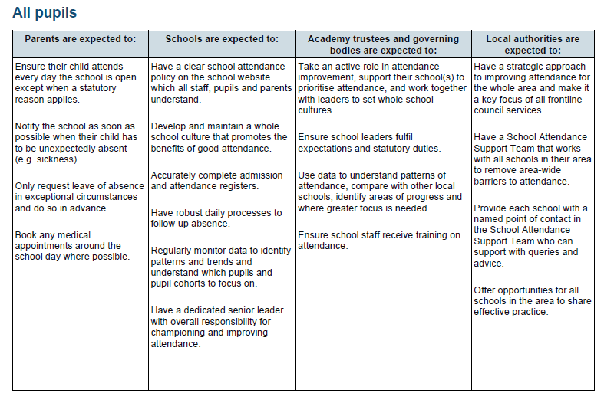

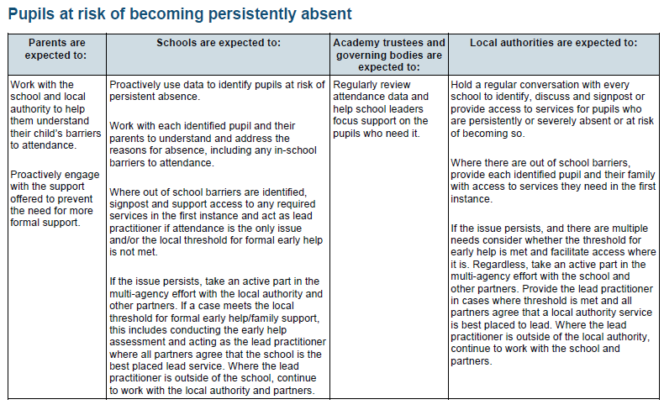
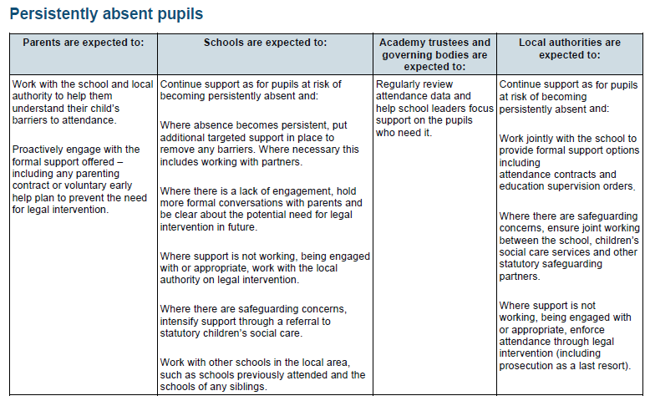

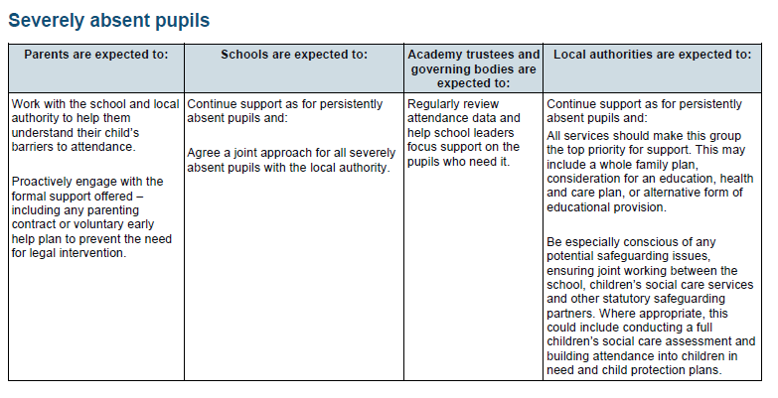

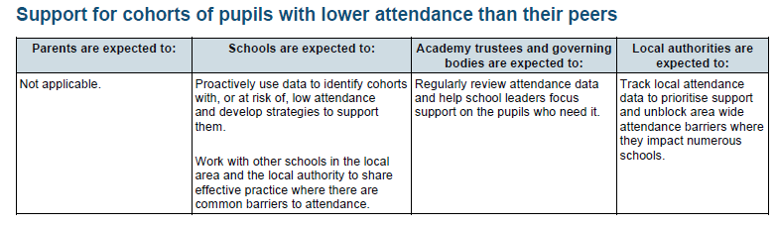
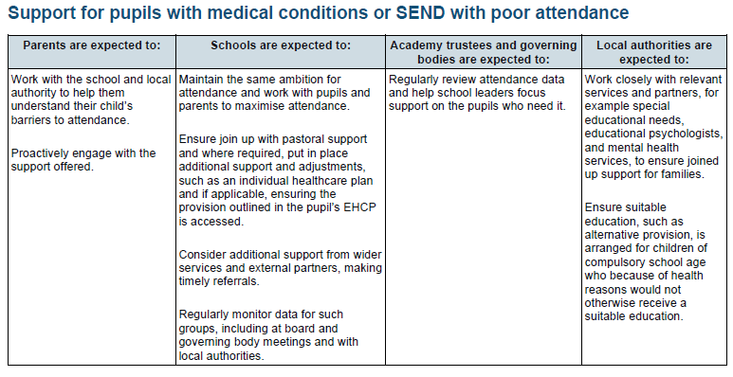
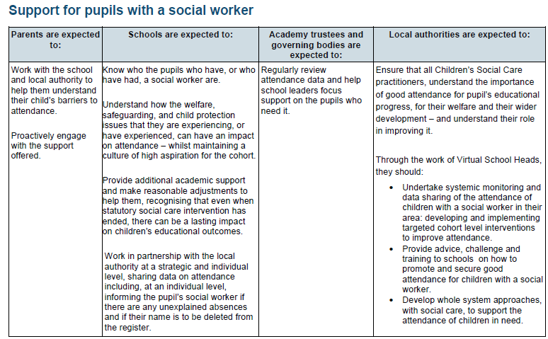

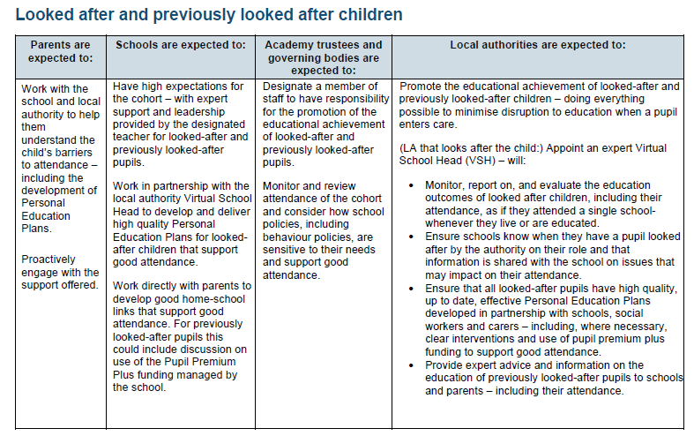

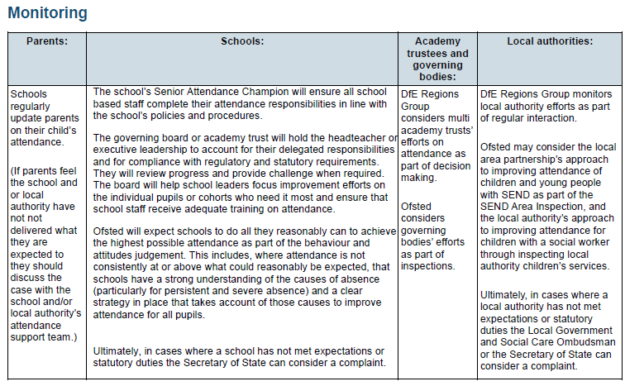

Annex B - East Sussex County Council

Code of Conduct – Penalty Notice for Unauthorised Absences and procedures for Schools and Academies

East Sussex Penalty Notice Code of Conduct for unauthorised absence

Penalty Notice Procedures for Schools and Academies

Annex C – Illness Absence Guidance

DfE external document template (childrenscommissioner.gov.uk)

 | Attendance Recovery – Individual Checklist
CYP name: | Click here to enter text. | Date of birth: | Click here to enter text. |  |  | School name: | Click here to enter text.
School Factors |  |  |  |  | Home and Family Factors
Breakdown of contact with pupils and parents |  |  |  | ☐ | Parent or family member currently unwell |  |  | ☐
Absence of key staff member |  |  |  | ☐ | Parental anxiety in sending their child to school |  |  | ☐
Changes in usual routines, lessons, organisation of classes |  |  |  | ☐ | High levels of financial family stress |  |  | ☐
Widening of attainment gaps due to poor attendance and engagement in learning |  |  |  | ☐ | Family history of school absence |  |  | ☐
Return to new classroom, teacher, peer group |  |  |  | ☐ | Family isolating / trying to stay away from others |  |  | ☐
Part time timetables / phased returns |  |  |  | ☐ | Parental loss in confidence in school’s teaching capabilities |  |  | ☐
Bullying and incidence of racism |  |  |  | ☐ | Increased risk of domestic violence / abuse |  |  | ☐
 |  |  |  |  | Insecure housing |  |  | ☐
 |  |  |  |  | Abuse or neglect |  |  | ☐
 |  |  |  |  | Parents working as keyworkers and creating an increase in autonomy |  |  | ☐
 |  |  |  |  | Young carer |  |  | ☐
CYP Factors
Avoiding social situations due to being absent |  |  |  | ☐ | Deterioration in friendships |  |  | ☐
BAME |  |  |  | ☐ | Young people entering employment |  |  | ☐
Anxiety relating to being in the school environment due to increased risk |  |  |  | ☐ | Preference to new routine established during time away from school |  |  | ☐
Fear of being away from the protection of parents |  |  |  | ☐ | Separation anxiety from parent increased |  |  | ☐
Fears of parents becoming ill |  |  |  | ☐ | Exploitation into criminal or antisocial behaviour |  |  | ☐
Refusal to re-engage in learning due to perceived benefits of virtual learning |  |  |  | ☐ | Radicalisation |  |  | ☐
Loss of confidence in learning |  |  |  | ☐ | Poor sleeping patterns due to lack of structure and routine. |  |  | ☐
History of prolonged absence |  |  |  | ☐ | Isolation of whole family or individual |  |  | ☐
Issues with transport |  |  |  | ☐ | Concern about keyworkers in family going out to work |  |  | ☐
Physical illness |  |  |  | ☐ | Uncertainty about the future |  |  | ☐
Child taking on the carer role within the family |  |  |  | ☐ | Lack of confidence in adults and their decision making |  |  | ☐

Example Nudge Letter
<school name>
<school address>

<Parental Salutation>
<home address>

<Date>

Dear <Parent/Carer Name>

Student/Pupil Name & Class

At <School Name> we strive to improve the attendance of our students. Each minute of the school day provides opportunities for learning, and it’s noticeable when students miss time.

<Student/Pupil Name> has missed <insert days and % attendance lost> of this school year, more than the typical <student/pupil> at our school for the same class/year.

We are worried that if <Name> continues to miss school days, it will be difficult to stay on track in the classroom.

Please call <named school contact> if you wish to discuss this further or need some support with <name>’s attendance.

Yours sincerely

Daily Attendance Guidance for monitoring of vulnerable students
Schools should have a ‘priority call list’ of students who are deemed vulnerable and very vulnerable (CP plan, CIN, LAC, GRT, EHCP, SEN, PA, SA, EBSA, YJS) and those where there are safeguarding concerns. All pupils’ absences should be monitored and tracked.

All Pupils
Timely registers taken in class.
A phone call should be made at the earliest opportunity for all students on the priority call list who are absent on Day 1
Amend register.
On day one of absence

Phone all contact numbers.

Ask friends.

Send letter/email asking for contact.
On day two of absence

Phone all contact numbers.

Ask friends.

Check with any multi-agency professionals if involved (ISEND/EHKW/Health/
Social Care)

Door knock, leaving a letter requesting contact.
If open to Social Care, contact Social Worker or Early Help Key Worker. If LAC also contact the relevant Virtual School
Timely closing of registration (no later than 30 minutes after the start of school day at the latest)
Contact all pupils without a known reason for absence.
Amend register and monitor attendance.
Phone call should be made and follow up with letter or email requesting contact.
If there is no response, follow attendance monitoring and tracking process and consider adding pupil to the priority list if identified as vulnerable.
No Response
Response
Response
On day three of absence

Phone all contact numbers.

Door knock/Home Visit

Where there is no response contact 101 Police welfare call line

If case meets level 3 or 4 on the ‘Continuum of Need’, contact SPOA with chronology.
No Response

RECORD OF CONTACT WITH PARENT/CARER regarding Attendance concerns
Section 1: Child’s details
 | Child’s Name (include any AKA)
 | Date of Birth
 | School
 | School Contact |  | Contact number
Name of Parents/Carers
with PR/Day to Day Care
 | Attendance %
 | Date of meeting/phone call with parent (please stipulate) |  | Discussion/meeting took place with:

Section 2: Please record details of the conversation with parents and any agreed actions:
Reasons for absence/barriers to education
Attendance % on date of meeting/contact.

Guidance note (please delete before sending to parent)
Ensure that all possible difficulties are considered, such as illness, anxiety, unmet SEN, transport etc

Section 3: Next steps and agreed actions:

 | Please state clearly what the parent has agreed to do to improve attendance:
 | Action to be taken | Who by? | When by? | Review of action

Next attendance review date:

Step by Step Guide to First Day Calling
When no reason for absence has been provided by the parent/ carer, schools should as a minimum follow the below steps.

Pupils deemed at risk | Pupils deemed at high risk should be treated as a priority:  - Children subject to a child protection plan  - Looked After children.  If these children are absent and there has been no contact - notify the key worker/contact within the first 24 hours.  - It is suspected or known that a pupil is at potential risk of harm.  - There is information that a pupil is, or may be, a victim of criminal activity.  - At risk of Child Sexual Exploitation (CSE)
Day 1 of absence | - Send absent text to parent/carers (if facility to do so)  - Telephone parents/carers if a response is not received following the text, leave a message if possible.  - Record actions on Schools Information Systems
Day 2 of absence | - Send absent text to parent/carers (if facility to do so)  - Telephone parents/carers if a response is not received following the text, leave a message if possible.  - If no response - telephone all contacts on Schools Information Systems, if no answer leave message to return call  - If international dialling tone is heard, leave message advising of this and ask for a call back.  - This may indicate they are on holiday and have not notified the school.  - If you believe this to be the case, send a ‘believe absence is a holiday’ in the fixed penalty information pack. Penalty notices | Czone (eastsussex.gov.uk)  - Letters should be sent separately to both parents first class.  - Record all actions on Schools Information Systems.
Day 3 of absence | - Send absent text to parent/carers.  - Telephone parents/carers, if a response is not received following the text leave a message if possible.  - Telephone all contacts on Schools Information Systems, if no answer leave message asking them to return the call  - Make home visit - if there is no answer leave calling card and move to next step.  - Send a letter of concern for absence, first class to all parents/carers and those with day-to-day care.  - Record all actions on Schools Information Systems.
Day 4 of absence | - Send absent text to parent/carers (if facility to do so)  - Telephone parents/carers if a response is not received following the text, if there is no answer, leave a message if possible.  - Telephone all contacts on Schools Information Systems, if no answer leave message to return call.  - Record all actions on Schools Information Systems
Day 5 of absence | - Telephone parent / carers and leave a message if possible and then follow up with an absence text.  - Telephone all contacts on Schools Information Systems, if no answer leave message to return call.  - If you believe this family are not on holiday and are concerned about the child’s welfare request a welfare visit from the police.  - Record all actions on Schools Information Systems.
Day 6 – 8 of absence | - Send absent text to parent/carers (if facility to do so)  - Telephone parents/carers if a response is not received following the text, leave a message if possible.  - Telephone all contacts on Schools Information Systems, if no answer leave message to return call  - Either send a further letter or make a further home-visit. If there is no answer leave calling card and move to next step  - Record all actions on Schools Information Systems
Day 9 - 10 of absence | - Send absent text to parent/carers (if facility to do so)  - Telephone parents/carers if a response is not received following the text, leave a message if possible.  - Telephone all contacts on Schools Information Systems, if no answer leave message to return call  - If you have not done so already, and you believe the family are not on holiday and are concerned about the child’s welfare, request a welfare visit from the police.  - Send a further concern letter separately to both parents / carers by first class post stating: You are making a referral to the Local Authority as their child is now considered Missing from Education  - Contact the Children Missing Education Team 01273 481967 to discuss whether appropriate to submit a Child Missing Referral and checklist.  Attendance and behaviour - Off Rolling: a notification if a child is missing education - Child Missing Education (CME) - Czone (eastsussex.gov.uk)
Missing Pupil Checklist | Must be completed by the 10th day of absence, when one of the following criteria applies:  - A pupil has gone missing, and no contact can be made with parent/carer to establish reason for absence.  - A pupil ceased to attend the school and forwarding address of the family is not known.  - A pupil has not returned from holiday within 10 school days of the expected date of return.  - A pupil fails to take up their place at the start of the academic year and the whereabouts of the young person is unknown.  School must continue investigations, while the Local Authority undertake their investigations.  Always keep in mind your requirements under Keeping children safe in education 2024 (publishing.service.gov.uk)
Day 11 - 19 of absence | - Send absent text to parent/carers (if facility to do so)  - Telephone parents/carers if a response is not received following the text, leave a message if possible.  - Telephone all contacts on Schools Information Systems, if no answer leave message to return the call  - Make another home visit during this period and leave a calling card.  - Inform parents / carers in writing that their child is at risk of being removed from roll.  - Record all actions on Schools Information Systems
Day 20 of absence | - Send absent text to parent/carers (if facility to do so)  - Telephone parents/carers if a response is not received following the text, leave a message if possible.  - Telephone all contacts on Schools Information Systems, if no answer leave message to the return call  - You cannot remove a child from roll until you have received notification from the Local Authority  - Record all actions on Schools Information Systems
Coding: | - These absences must be coded as O for unauthorised absence due to no valid reason provided by parents/carers.  Please contact your schools SPOC for any advice and guidance



Attendance Targeting Support Meeting Record
Meeting One
School /Setting Name: |  | Date of Meeting:
School Attendees (should include the attendance operational and SLT leads): |  | Role(s):
ESCC Attendance Support Team (AST): |  |  | Single Point of Contact (SPOC)

Welcome and general check in:

Based on the school’s data analysis what are the emerging needs around attendance?  Emerging Needs? (school to provide) | Choose an item.
Key priorities based on School’s Data Analysis:
AST and School to discuss issues and strategies for data sets presented. AST and school to discuss cohorts and issues identified.

TASS DATA
Current position against geographical TASS area/statistical neighbours / national and horizon scanning.
Add data sets in this box

AST to provide attendance data headlines
AST team to complete before going in to schools.

AST will complete the school’s data as below:

Overall Absence -
Persistent Absence -
Severe Absence -

- What does the data tell us?

School Data
School to prepare and share information on cohorts identified below

Part time timetables (how many C2 codes and for how many pupils)
CP -
CIN -
SEND -
FSM -
PP -
(all individual columns )

- Analysis by registration codes:
- Contribution of E on overall absence in one academic year,
- B 10+ sessions,
- C 10+ sessions

- Punctuality and lateness trends

All individual columns (all one table)

For schools with specialist facilities:
AST to complete this section, including meeting with facility lead to discuss any attendance barriers/issues/support

How is attendance monitored and supported?

Attendance Matters updates and feedback –
AST complete this section

TASS newsletter – has it been shared?

DfE updates:

ESCC updates :

Toolkits/processes/procedure updates

Schools / LA good sharing practise

Attendance forums and network meeting facilitated by LA

Identified Training Needs:

What?

Who?

When?

TRADED – Cohort/Group work
Support of pupils/parents/carers by a TASS practitioner based on emerging trends/issues. (AST to provide a maximum of six sessions)

What?

Who?

When?

Tier Two
When attendance reaches 92%, there is already a cause for concern, an ideal way to look at the barrier, and how it is being unpicked and supported is by using an assess, plan, do, review, a circular document. The focus of this should be the reason that attendance has been impacted upon. There are notes to guide as to what should be included in this document. You can use the East Sussex template, or one of your own, but it should include an assessment to identify the concern, a plan to overcome it, actions that are taken to address it, and a review to show what has worked. At this point the cycle can be continued or restarted to address any new arising concerns.
When there are additional vulnerabilities or such as SEND or complex needs, an additional needs plan needs to be implemented, with a clear focus on attendance. If a parent and pupil voice, have already been gained it is a good time to review and revisit these documents at this stage. If they haven’t been gained, they would be beneficial to assist in the identification of the prevailing reason for absence as well as assisting in identifying themes and trends for absence. Consideration should be given to formalising supportive measures on an attendance support plan.
School avoidance and anxiety may be driving factors in the current decline in attendance, support for anxiety(Mental health and emotional wellbeing (MHEW) | Czone (eastsussex.gov.uk) and EBSA (emotional based school avoidance) (EBSA toolkit | Czone (eastsussex.gov.uk) along with their toolkits can be found on CZONE. (Czone | Czone (eastsussex.gov.uk)
Should a part time timetable be considered, you should use the reflective checklist, to consider if it is appropriate, and follow the guidance to ensure that it is reviewed regularly and only used for the minimum time necessary. Any periods that the pupil is not expected to attend should be recorded as C2 on the attendance register.
Have you considered how much effect punctuality can have on attendance? Could this be something that can be supported to improve attendance?

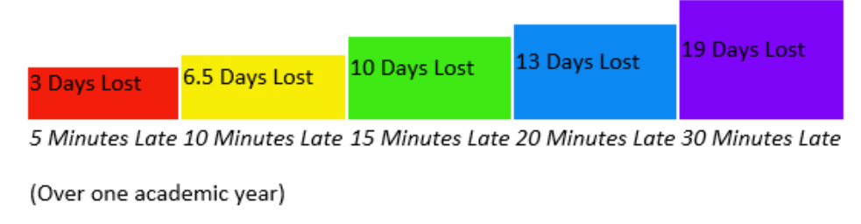

Attendance Asses, Plan, Do, Review
Name of child/pupil: DOB: Year Group:
Member(s) of staff completing (position): School:

Step 2
Pick out no more than 3 specific areas for improvement,
This might be :
Improved attendance
Reduce number of lates
Improved and consistent communication with parents

Outcomes
What do you want to achieve?

STEP 1 Describe the difficulties and highlight the key issues regarding attendance at this time. e.g Current attendance percentage%. Explore if there Is a pattern e.g. of every Monday they are absent? What are the current reasons for absence? What has been tried to encourage attendance due to these absences? Does the family have other support currently, from social care for example? This should be a summary and bullet points may be best.
Child factors = anxiety, low self esteem, difficult behaviour? Family factors = Separation, conflict, poor mental health? School factors= transition, bullying, relationships?

Date started
Assess
What is the current situation


REVIEW
Review outcomes

Step 3 Linked to the outcomes above.
For each outcome list how the child and family will be supported to achieve this. What strategies, support and intervention will be in place.
This should be a summary, so bullet points are fine. For example:
Invite parents in for a meeting to discuss lates / attendance / parenting contract/ setting targets for attendance and communication to improve/ daily calls/ offer of transport/ support agencies groups offered, etc
Warning letters to be sent regarding lates following the meeting, then FPN`s? for example.
Add support to be put in place identified in Assessment

Do
Identify actions/ next steps

Step 4
Use this section to record review meetings with parents and targets set for attendance
Then look at each of the outcomes in turn and discuss how far they have been met. For outcomes that have been met they will need to be changed to a new one. For those that have been partially met or where there has been improvement the outcome may just need to be adjusted.
The review is also a key opportunity to look at the DO section and confirm that everything in there was put into place. What has been the impact of each strategy/intervention? – make changes to this section.
What other steps will now be taken, for example has a penalty notice warning been issued and now is time to request, or refer to other services?

Guidance notes from for schools when completing Assess Plan Do Review cycle regards school attendance issues and referrals for additional support

Assess
- Current Situation – include relevant baseline attendance information including resilience and risk factors: How often has the pupil attended school in the last few days/weeks/months?
- Analysis of register data – trends, patterns and reasons given for School Absence
- Is there a history of attendance difficulties?
- Pupil factors - introverted personality, low self-confidence, poor self-concept, tendency to be overwhelmed by stress, clingy (“behavioural inhibition”), anxiety, social communication difficulties
- Family factors - conflict, parent separation/divorce, poor parental mental health, loss/bereavement (stereotypically – overprotective/distant parenting), early attachment difficulties, trauma, neglect
- School factors - transition, bullying, social isolation, academic problems, instability of school personnel, poor pupil-staff relationships
- What is the main function of the absence? For e.g. is it medical, emotional difficulties, anxiety, separation anxiety, parentally condoned absence, truancy

Plan (what do we want to achieve as outcomes)
- Identify protective factors
- Educational consequences – improved attendance results in improved attainment
- Develop shared goals – achieve their potential to the best of their ability
- Pick out no more than 3 specific areas for improvement
- This could also include specific targets:
- Improved attendance
- Reduced unauthorised absences
- Fewer lates
- Improved and consistent communication between concerned parties i.e. attending meetings, regular discussions with school and parents
- Collaborative working between school, parent and CYP i.e. acting on advice and strategies

Do - strategies & targeted interventions based on the function of absence undertaken by school
- Direct communication between parents and school (agree expectations regarding frequency and methods of contact as well as response times)
- If the pupil is not attending, a return to school at the earliest opportunity
- Home visits by school staff as needed
- Realistic and achievable targets
- A personalised programme of support for the pupil (and perhaps interventions for parents/family if needed)
- A ‘key adult’ in school and a ‘safe place’ where the pupil can go to if needed
- A way of ensuring all school staff (and any visiting teachers) are informed about the pupil’s needs, objectives and support strategies
- For each outcome list how the child and family will be supported to achieve this. What strategies, support and intervention will be in place
- This should be a summary, so bullet points are fine
- Pupil voice
- Parent voice
- Reasonable adjustments made based on assessment of needs

Review
- Review outcomes and include progress made against outcomes and interventions
- Then look at each of the outcomes in turn and discuss how far they have been met. For outcomes that have been met they will need to be changed to a new one. For those that have been partially met or where there has been improvement the outcome may just need to be adjusted.
- The review is also a key opportunity to look at the DO section and confirm that everything in there was put into place. What has been the impact of each strategy/intervention? – make changes as appropriate to this section.



Attendance Success Plan

The following may seem in a strange order, it is a booklet that can be printed and shared with students to support them making decisions to improve their attendance. (It needs to be printed on A4 paper, flip on short side, to create the booklet)

This booklet can be amended to suit the school, or amended to suit needs of an individual pupil as appropriate.



Other places I can get support include: | My  Attendance  Success  Plan  Name:  Class/Tutor:
  East Sussex County Council - Information for families | East Sussex County Council
  IROCK: Support and advice for young people in East Sussex @ IROCK (irocksussex.com)
  YoungMinds | Mental Health Charity For Children And Young People | YoungMinds
  e-motion Counselling
  Young Carers
  NSPCC | The UK children's charity | NSPCC
  School Nurse Team
  Childline | Childline
  Text "SHOUT" to 85258 to contact the Shout Crisis Text Line, or text "YM" if you're under 19

At School  Please complete the following:  My named school contact:  Their Contact details:  When I am struggling I can go to (room) :  If this person is not available, I can go to:  In room:  My current attendance level is:  My target for next week is:  My target for this term is:  My target for the school year is:   | Use this calendar as a guide to mark off days that you have attended school, and the days that you are meeting with your nominated school contact, so you have a reminder of how you are doing, and when you can access support.  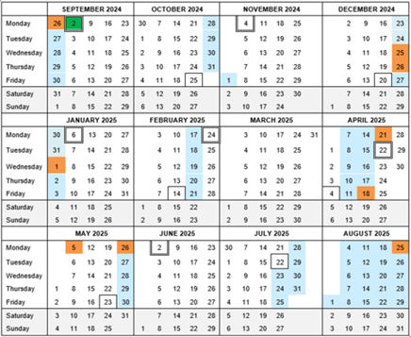

Take another look at your plan together and see what is going well, today’s date: | It is important to be in school, here are some reasons why  - Making friends, you meet people at school that you may not meet outside of school. You may find that these people like the same things as you do. You wouldn’t meet them if you didn’t go, and spending time with friends can make you happy, and the day go by fast.  - If you are in school, you are safe, the teachers and staff are there to look after you and keep you away from harm.  - Learn how to do new things. We go to school to learn, we learn how to be friends, how to behave with other people, how to do new things, as well as taking part in the classroom lessons.  - Going to school can help you get ready for adult life, it gets you in routines, understand how to plan your day, and how to deal with problems when they come up.  - School is also about completing lessons, learning subjects, and taking exams to see what you have understood and learned. All skills that you will need as you grow up and move on.
  Identified Area (s) | What worked well and what didn’t why?
  
  What’s working now? | What shall we try?
Thinking about things that stop me from attending school on somedays:  See if you can think about things that may be barriers to coming to school, and how they make you feel.  Here are somethings that other people have said that sometimes stop them from coming to school, maybe they apply to you, tick any that do and write down anything that isn’t here:  Transport – getting to school  Lessons are difficult or I don’t understand them  I don’t have friends here  I feel that I am bullied  I help with brothers and sisters and that makes me late/stops me coming  I don’t like a teacher  I don’t like other people in my class  Something else: | Take another look at your plan together and see what is going well, today’s date:
  Identified Area (s) | What worked well and what didn’t why?
  What’s working now? | What shall we try?

Now review your answers, and make a plan with your school contact, today’s date : | Being late to school can also affect your attendance:  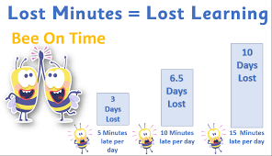  Have a think about what you can do to make sure that you are on time here, you could write down what you will do to get to school on time, or to the bus stop or train station on time…..  Here are some ideas:  Get ready the night before  Pack your bag and lay out your uniform  Know where your money or pass are to get a bus or train  If you have to take medication in the morning, put it somewhere safe the night before  Set your alarm, have plenty of time to get ready
  Identified Area (s)  Relationships  Communication  Bullying  Access to curriculum  Transport | Action Plan
  Review – how it’s going. | Resources and support

Helping Myself:  Possible Strategies to REACH MY Attendance Goals  - I will make attending school and every class on time every day a priority.  - I will keep track of my attendance and absences.  - I will maintain a bedtime routine and set my alarm for ______ a.m.  - I will find a relative, friend or neighbour who can take me to school if I miss my bus or train.  - When I am struggling with a challenge that is keeping me from school, I will confide in an adult at school and seek help. I will think about friends and adults that can help me.  - I will attend school every day unless I’m sick with a contagious illness.  - If I cannot avoid missing school, I will contact my teachers to ask for materials and find out what I missed.   | You have 190 days a year to attend school, which means 175 days to do what you want – that’s 4200 hours that you aren’t at school.    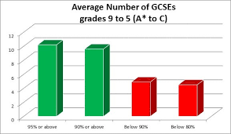
At School  Please complete the following:  My named school contact:  Their Contact details:  When I am struggling I can go to (room) :  If this person is not available, I can go to:  In room:  My current attendance level is:  My target for next week is:  My target for this term is:  My target for the school year is: | Use this calendar as a guide to mark off days that you have attended school, and the days that you are meeting with your nominated school contact, so you have a reminder of how you are doing, and when you can access support.

Student Support Profile/Additional Needs Plan / Targeted (delete as appropriate see guidance)
Name: | DOB: | Review Period: (highlight/delete)  Term 1 & 2  Term 3 & 4  Term 5 & 6

SECTION 1
Tutor Group/Form: | Year: | COP Level: |  | Category of Need: C&I  C&L  SEMH  S&P
Strengths: What do you like and admire about …? |  |  | Interests:
Any other key relevant information:

Parent’s/Carer’s Views:

Learner’s Views

I need you to know:

How you can help me: (Additional to those below)

How I can help myself:

SECTION 2

Highlight and/or add any support provided referring to The Universally Available Provision
Immediate feedback | Focused adult support | Movement breaks | Individualised visuals | Larger print/enlarged images | Additional processing time | Adapted Learning Objectives
Written feedback read to learner | Vocab or subject handbook | Writing Slope | Consistent talk/task partner | Coloured paper /backgrounds | Individualised Visual Timetable | Visual task planner
Ipad/laptop for written work | Visual reminders | Pencil grips/ergonomic pens | Targeted Questioning | Adapted seating | Quiet safe area | Fiddle object
Learning Break | Use of headphones | Individual workspace | Wobble cushion | Heavy lifting activity | Visual Instructions | Exam Access Arrangements

Subject Specific Adjustments:

SECTION 3 -Assess Plan Do review (APDR)

Initial Outcomes and Plan Date:

Assess  What can the learner do now? | Plan  What does the learner need to do next? | Do  Who will help the learner and how? | Progress the Learner has made
Assess  What can the learner do now? | Plan  What does the learner need to do next? | Do  Who will help the learner and how? | Emerging | Developing | Achieved
Other Comments

SECTION 4 - Progress Data
KS3
 | Year 7 |  |  |  | Year 8 |  |  |  |  | Year 9
Date | English | Maths | Science | Social/  Emotional | Date | English | Maths | Science | Social/  Emotional | Date | English | Maths | Science | Social/  Emotional

KS4
 | Year 10 |  |  |  | Year 11
Date | English | Maths | Science | Social/  Emotional | Date | English | Maths | Science | Social/  Emotional

Other assessment data:
Test | Date | Result | Date | Result | Date | Result | Date | Result
Language Link
Spelling Age
Reading Age

SECTION 5 – Area of Need
Area of Need: Communication and Interaction
Key Information (i.e Background, context, baseline)
Expected outcomes for 12 months’ time:

Outcomes Term 1: | Provision – Who will help, what will be provided and how often? |  | Review
Parent’s/carer’s view at review:

Learner’s view at review:

Outcomes Term 3: | Provision – Who will help, what will be provided and how often? | Review
Parent’s/carers view at review:

Learner’s view at review:

Outcomes Term 5: | Provision – Who will help, what will be provided and how often? | Review
Parent’s/carer’s view at review:

Learner’s view at review:

Area of Need: Cognition and Learning
Key Information (i.e Background, context, baseline)

Expected outcomes for 12 months’ time:

Outcomes Term 1: | Provision – Who will help, what will be provided and how often? |  | Review
Parent’s/carer’s view at review:

Learner’s view at review:

Outcomes Term 3: | Provision – Who will help, what will be provided and how often? | Review
Parent’s/carer’s view at review:

Learner’s view at review:

Outcomes Term 5: | Provision – Who will help, what will be provided and how often? | Review
Parent’s/carer’s view at review:

Learner’s view at review:

Area of Need: Social, Emotional and Mental Health (SEMH)
Key Information (i.e Background, context, baseline)
Expected outcomes for 12 months’ time:

Outcomes Term 1: | Provision – Who will help, what will be provided and how often? |  | Review
Parent’s/carer’s view at review:

Learner’s view at review:

Outcomes Term 3: | Provision – Who will help, what will be provided and how often? | Review
Parent’s/carer’s view at review:

Learner’s view at review:

Outcomes Term 5: | Provision – Who will help, what will be provided and how often? | Review
Parent’s/carer’s view at review:

Learner’s view at review:

Area of Need: Sensory and Physical
Key Information (i.e Background, context, baseline)
Expected outcomes for 12 months’ time:

Outcomes Term 1: | Provision – Who will help, what will be provided and how often? |  | Review
Parent’s/carer’s view at review:

Learner’s view at review:

Outcomes Term 3: | Provision – Who will help, what will be provided and how often? | Review
Parent’s/carer’s view at review:

Learner’s view at review:

Outcomes Term 5: | Provision – Who will help, what will be provided and how often? | Review
Parent’s/carer’s view at review:

Learner’s view at review:

Area of Need: Personal Development and Independence/Preparation for Adulthood
Key Information (i.e Background, context, baseline)
Expected outcomes for 12 months’ time:

Outcomes Term 1: | Provision – Who will help, what will be provided and how often? |  | Review
Parent’s/carer’s view at review:

Learner’s view at review:

Outcomes Term 3: | Provision – Who will help, what will be provided and how often? | Review
Parent’s/carer’s view at review:

Learner’s view at review:

Outcomes Term 5: | Provision – Who will help, what will be provided and how often? | Review
Parent’s/carer’s view at review:

Learner’s view at review:

PUPILS’ VIEWS ON ATTENDANCE DIFFICULTIES

This form is for pupils to share their voice around their barriers to attendance and help to support action planning around how best to support attendance.

PUPILS NAME:

STAFF MEMBERS NAME:

SCHOOL:

SCHOOL YEAR:

TODAY’S DATE:

WHAT STRUGGLES ARE YOU HAVING AROUND ATTENDING SCHOOL:
You can select more than one option, and if you can, tell me why you feel this way.

I know why don’t want to go to school | ☐
I have difficulty getting ready in the morning | ☐
I find it hard travelling to school | ☐
I find it hard to enter the school building | ☐
I have anxiety about going to school in the evenings before going to bed | ☐
I find some lessons difficult | ☐
I struggle with some of my teachers | ☐
I find breaktimes/transition between lessons difficult | ☐
Something else, tell me about it….

SCHOOL:

What do you like about school?

What do you dislike about school?

What subjects do you like?

What subjects do you find a struggle?

What worries you about coming to school?

HOME:

Who can you talk to at home about your anxieties/worries?

Do you feel listened to at home?

Would you like to spend more time with your parents/carers?

Do you have brothers and sisters (siblings)?

How is your relationship with your siblings?

What’s the best thing about where you live?

Is there something you don’t like about where you live? If so, what?

FRIENDSHIPS/HOBBIES:

Tell me about your friends,

At school:

Out of school:

Hobbies:

What do you do to relax?

Can you let me know about the information below about which parts of the school day you find make you the most anxious/concerned/worried?
 | 1  Not at all anxious | 2  Sometimes anxious | 3  Anxious | 4  Quite anxious | 5  Extremely anxious
Travelling to school
Getting into the school building
Registering/ start of the day
Particular lessons
(which ones)
Transitioning between lessons
Working independently
Working in groups
Assessments and/or exams
Breaks/lunch times
The end of the school day
Homework

Other (please specify)

WHAT DO YOU FEEL NEEDS TO CHANGE TO ENABLE YOU TO ATTEND SCHOOL AND ENGAGE IN LEARNING

PLEASE LET THE ME KNOW IF THERE IS ANYTHING IMPORTANT YOU WOULD LIKE US TO KNOW THAT IS HAVING AN IMPACT ON YOUR ATTENDANCE

THANK YOU FOR YOUR TIME AND SHARING YOUR VIEWS, THIS WILL ENABLE US TO SUPPORT YOU IN IDENTIFYING AND ADDRESSING THE BARRIERS THAT ARE PREVENTING YOU FROM ATTENDING SCHOOL.

Pupil Voice – when pupil not attending
Education Division

Child’s Name:

DOB:

School:

Last date of school attendance:

School Key Adult:

Other professionals supporting:

Learning
What are you good at? What types of learning do you enjoy? (Creative activities, sports, science, problem solving, working with others, learning something new)

How do you like to learn? (Being support by the teacher/support staff, having something explained more than once, having time to think, being read to, support with writing my ideas down)

Barriers to learning (What could stop you from learning? What do you find difficult? Reading, writing, sitting still, keeping focused, answering questions)

Your thoughts about going to school
When you were last in school?

What do you think about school? Is it important to you?

How do you feel about returning?

Favourite subject/s?

Least favourite subject/s?

What do you miss about being in school? (Being with friends, being out of the house, not doing lessons I enjoy, learning)

Behaviours and Emotions
Can you control your behaviour?

I struggle to stay calm Sometimes I can stay calm

10 9 8 7 6 5 4 3 2 1

Are there any types of inappropriate behaviours you could to do in school? (Swearing, fighting, shouting, running, leaving class or school, distracting others)

What types of appropriate behaviours are you able to use in school? (Paying attention, listening, asking for help, completing schoolwork, not distracting others)

What would be a good day for you at school? (No distractions, feeling supported, seeing friends during breaks and lunch, knowing what to do in classes)

What could be a bad day for you at school? (Getting detention, falling out with friends, find the classwork difficult, not knowing what to do, other distractions)

When something goes wrong at school what could happen to support you?

What happens when you think things are unfair? How does that make you feel?

I’m happiest when….

What upsets me most….

Being in the learning environment

How do you learn best? (Being supported by the teacher, being read too, sitting at the back of the class, support with writing, working with in a pair)

Do you think a time out card would help? (There will be expectations around its use)

Did you have a safe space/adult to go to previously? Did this work?

Do you know anyone at the school? Friend/foe

Have you previously experienced bullying?

How do you feel about not being with mum/dad/carer all day?

Does school make you feel safe or unsafe?

Year 10/11 only:
Do you have any ideas about what you would like to do post 16?

How do you feel about GCSEs?

Support:
What things would you like to be in place to help you?

Child/Young Person Signature……………………………………………………………………

Child/Young Person Full Name………………………………………………………………….

Date………………………………….

Parent Views
PARENTS’ VIEWS ON ATTENDANCE DIFFICULTIES

This form is for parents to share their voice around their barriers to their child’s attendance and help to support action planning around how best to support attendance.

PARENT’S NAME:

PUPIL’S NAME:

SCHOOL:

CURRENT SCHOOL YEAR:

TODAY’S DATE:

CURRENT DIFFICULTIES:

My child expressing that they don’t want to go to school | ☐
Difficulty getting my child ready in the morning, or out of their room or bed | ☐
Difficulty travelling to school or entering the school building when they arrive | ☐
My child reporting frequent stomach-aches  /headaches/illnesses etc | ☐
Signs of anxiety in the evenings before going to bed. | ☐
My child being unable to go into school on some days | ☐
My child is not able to attend school for days at a time. | ☐
My child is not currently attending school | ☐
Struggling to access learning, part or all of the curriculum | ☐
Reports issues with friends and peers | ☐
Struggling to build or maintain inter-personal relationships (Peers and/or adults) | ☐
SEND concerns (diagnosed / undiagnosed) or unidentified needs | ☐
Other,
Please describe if possible:

SCHOOL BASED CONCERNS:

HOME BASED CONCERNS:

CONCERNS YOUR CHILD HAS EXPRESSED TO YOU:

WHICH MEMBERS OF STAFF DOES YOUR CHILD HAVE A GOOD RELATIONSHIP WITH?

WHAT DO YOU FEEL NEEDS TO CHANGE TO ENABLE YOUR CHILD TO ATTEND SCHOOL/ENGAGE IN LEARNING?

By yourself as a parent

From the School

From your child

From any other services / professional (eg social care, health services, and other education services?)

WHAT IS WORKING WELL FOR YOUR CHILD IN SCHOOL?

PLEASE LET THE US KNOW IF THERE IS ANYTHING IMPORTANT YOU WOULD LIKE US TO KNOW THAT IS HAVING AN IMPACT ON YOUR CHILDS ATTENDANCE.

NEXT STEPS:

THANK YOU FOR YOUR TIME AND SHARING YOUR VIEWS.
THIS WILL ENABLE THE SCHOOL AND OTHER PROFFESIONALS TO SUPPORT YOU, IN ENABLING YOUR CHILD’S REGULAR SCHOOL ATTENDANCE.

Parent/Carer View (when child is not currently accessing school)
Education Division

Child’s name:

DOB:

EHCP:
APO:
Last date of school attendance: attended:
School Key Adult:

Other agencies supporting young person/family:

Key Information:
Diagnosis:

EHCP/SEND Information:

Are there any services involved? Do you and your child have support?

What was Primary school like for your child?

What key information do the school need to know?

If Previous Elective Home Learning
Why did you remove your child from mainstream education?

What worked well for home learning?

What reasons did things not go well?

Your thoughts on returning to school

How will they travel to school?

How do you feel about the allocated school for your child?

What are your concerns around your child attending school? (Attending school, traveling to school, being in the learning environment, interacting with other pupils, you felt unsupported)

Did/do you have a good relationship with the school? (Communication, staff where approachable, understanding of your child)

Did you feel your concerns were heard?

Do you think your child can be successful at school?

What support would you like to see in place for your child’s return to school?

Home Environment:
What is your child’s behaviour like at home? (Are there any triggers? Is this after school or before school? Sleep patterns)

What steps do you take to support your child?

Has there been any significant changes at home/life events?

What is the relationship like between siblings in the home/school?

Does the thought of your child returning to a school environment make you worried?

Do you feel your child is safe at school?

Has your child previously experiences bullying?

How did the school support with this?

Year 10/11 only:
Do you have any ideas about what your child would like to do post 16?

How do you feel about your child taking their GCSE?

Parent /Carer/Guardian Signature………………………………………………………………….

Parent/Carer/Guardian Full Name………………………………………………………………….
Date………………….

Tier Three
When a pupil reaches tier three there should be an assess, plan, do review, and if appropriate and additional needs plan in place. With evidence of reviews that have taken place. Parent and pupil views should be reviewed to see what has been trialled, what has worked and what hasn’t to ascertain if new supportive measures need to be implemented.
Schools can move to using an attendance support plan, to formalise the measures that have been used, if this has not already been completed. To identify what the young person, school and parent/carers are taking responsibility for, to encourage and support improved attendance.
To evidence that a parent/carer has been invited to attend the school a letter should be sent via first class post, copies of an assess, plan, do, review or support plan should be shared with the parent/carers, and both the parent/carers and pupil should have input into the formulation of these supportive documents.
If during the meeting fixed penalties for unauthorised absences are discussed this should be followed up with a letter outlining this discussion. If a parent fails to attend, they should also be sent a letter, offering to reschedule. Should the parent fail to engage, you can complete and send the appropriate plan, and note what steps have been taken to ensure that the parent can attend and engage in this supportive process, you should continue with its implementation.
An attendance contract should also be considered, as this will formalise all steps that have been taken, and gives the opportunity for you to discuss with the pupil, and parent / carers the seriousness of the current attendance levels, and gives the warnings that are necessary should legal interventions become the next appropriate steps.
The DfE also have template letters that can be used Working together to improve school attendance - GOV.UK (www.gov.uk).



Attendance Support Plan (The following plan details actions to be taken to ensure a positive improvement in Attendance.)
Section 1: Child details

 | Child’s Name (include any preferred names or aliases)
 | Date of Birth
 | School
 | Key School Contact |  | Contact number
 | Name of Parents/Carers
 | Relationship to child
 | Address
 | Contact number(s)
 | Date of Meeting |  | Present at Meeting
 | Start Date |  | Present at Meeting
 | Proposed End Date |  | Present at Meeting
 | Does the child have an identified SEN? |  | EHCP?

Section 2: Issues that this plan will address?
Attendance % at date of meeting and Attendance % for the last two terms or more as deemed appropriate by school.

Number of days of lost learning =

Authorised absences % / days =
Unauthorised absences % / days =
Has bullying been raised by the pupil or parent as a reason for irregular attendance? Yes/No
Record details here and support provided.

Persistent lateness to school? Yes/No
Investigate any barriers.
Consider reasonable adjustment for a short period if there are genuine difficulties.

Not in school due to: (anxiety- mental health- wellbeing)
Unpick any barriers.
Keep a record of support offered, what services can the school offer to support, or refer to, has an ANP been initiated?

Medical reasons / diagnosed or undiagnosed:
Medical evidence to be discussed and provided- is there a consultant involved? Do we need to initiate a meeting with School health / SENDCo to formulate a care plan and add reasonable adjustments in? Does the school need to create an Individual Health Care Plan (IHCP)?

Parental health – is this a barrier and has support been considered/sign-posted to?

Parenting support – discuss referral EHKW? Discuss support such as CLASS +, Spectrum - please see local offer.

School issues, relationships: school areas to address in conjunction with young person, how can school build positive relationships? Support with creating a peer group?

S.E.N, met/unmet needs/ unidentified barriers to learning:
What assessments have been considered/ carried out? Boxall, Thrive, SDQ, DST, Language Link, Sensory Profiling, links with EP, CLASS adviser, Inclusion Adviser.

Access to curriculum: – any difficulties to be addressed? Consider reasonable adjustments.

Engagement from parents: is this a barrier? Gather parent voice and review the barriers to accessing education.

Transport issues: is this a barrier? School support may be considered in the interim whilst a longer-term plan is initiated.

Section 3: Outcomes
 |  | The following OUTCOMES should be expected with implementation of agreed strategies.
1.Increased attendance by reducing unauthorised absences.

2. Improved attendance to be maintained.

3. Effective communication with all parties.

These can be amended to suit the individual pupil and family plan, and additional outcomes may be added.

 | What the Young Person will do |  |  |  | Review 1 | Review 2 | Review 3
 | - Add personalised target/s and goals
 | Young Person’s Signature: |  | Today’s Date:

Section 4: School’s actions
 | How will the School address needs: |  | Review 1 | Review 2 | Review 3
 | - To be personalised to support and address any barriers and emerging needs of the individual pupil and family.
 | I agree to action the above points
 | Key Contact Signature: | Name:
 | Contact Number: | Today’s Date:

Section 5: Parenting agreement:
 | If parents/carers did not attend the meeting, what strategies have been tried to engage them with this plan? N.B. this section cannot be left blank if the parent/carer did not attend.
 | Every attempt to be made to reach out and offer support. The support strategies offered and undertaken can be listed in this box. These can include phone/virtual/home meetings as an alternative.
 | The parents/carers will: | Review 1 | Review 2 | Review 3
 | - Add in here a personalised targets for the parents/carers

 | I agree to action the points above and understand that failure to engage in supporting strategies will be a factor taken into account to initiate a formal Attendance Parent Contract
 | Parent / Carer Signatures:  1.  2. | Name:
 | Contact Numbers: | Today’s Date:

Section 6: Other Agency involvement / review

Other Services /Agencies :
Record other services that are present for the meeting, and support that they are offering, or services that you may consider referring to.

Review Arrangements:
End Date of plan: TBC

OPTIONAL – Referral and Recommendations
DELETE AS NECESSARY:
Support sign posting:

Information for Families (advice regarding SEN and school admissions): 0345 60 80 192 / https://www.eastsussex.gov.uk/childrenandfamilies/information-for-families/

Triple P: https://www.triplep-parenting.uk.net/uk/triple-p/
For more information call the parenting team on 01424 725800 or email: TriplePteam@eastsussex.gov.uk

Open for Parents Young Peoples Top Tips for Parents – | Open for parents

Special Educational Needs and Disability (SEND) Information Hub. Helping parents and carers make informed decisions for their children.
https://isend.eastsussex.gov.uk/

East Sussex 1Space is East Sussex County Council's online directory. It brings together groups and organisations that offer care, support and wellbeing services to people in East Sussex.
https://1space.eastsussex.gov.uk/

Refer to local offer for parenting support:
https://www.eastsussex.gov.uk/childrenandfamilies/specialneeds/

For sleep support you can self-refer to the East Sussex School Health service:
https://www.kentcht.nhs.uk/service/school-health-service-east-sussex/

Refer to SPOA: https://new.eastsussex.gov.uk/children-families/professional-resources/spoa

Chat Health
https://chathealth.nhs.uk/

Spectrum (Parent self-referral)
https://czone.eastsussex.gov.uk/inclusion-and-send/isend-services/communication-learning-and-autism-support-service-class/spectrum-autism-support/

CLASS+ (Parent self-referral)
CLASS@eastsussex.gov.uk - 01273 336887
https://czone.eastsussex.gov.uk/inclusion-and-send/isend-services/communication-learning-and-autism-support-service-class/classplus/

irock: If you’re aged 14-25 and live in East Sussex then i-Rock is here to help you. https://www.sussexpartnership.nhs.uk/irock

Local support is available: https://czone.eastsussex.gov.uk/health-safety-wellbeing/mental-health-emotional/support-services/

Amaze: Amaze is a charity that gives information, advice and support to families of children and young people with special educational needs and disabilities (SEND) in Brighton & Hove and Sussex. They also support young people with SEND up to 25. https://amazesussex.org.uk

Post 16 support: Youth Employability Service – YES - https://www.escis.org.uk/advice/youth-employability-service-yes-east-sussex/

Bereavement:
Dragonflies (bereavement) 01424 855222 https://www.escis.org.uk/advice/dragonflies-project/

Winston's wish (bereavement) 080 880 20021 / 01242 515157 https://www.winstonswish.org/

St Wilfred's hospice aged 5-17 (bereavement) 01323 434257 https://www.stwhospice.org/

Bereavement service The Seahorse Project
Website: www.stwhospice.org/the-seahorse-project (referral online)
Tel: 01323 434200

Butterflies child and adolescent counselling service (fees apply) 01424 775187 www.butterfliescacs.co.uk Email butterflies.cacs@gmail.com

E-Motion : www.e-motion.org.uk (online counselling for 12-18)

Attendance Meeting Invite letter to parent

NB (Separate letters to be addressed to each parent if there is more than one)

Address 1
Address 2
Address 3

[Insert date]

INVITE

Dear (Parent)

Attendance Meeting Invite
On at
There are currently concerns regarding your child’s level of attendance at school. Despite this having previously been brought to your attention, there has been no improvement and, to date, we do not appear to have been provided with a valid reason for these absences.

Under the Education Act 1996, parents have a duty to ensure that their child attends school regularly and failure to do so is therefore an offence.

You are therefore invited to attend the above meeting where we can discuss and agree targets in an attempt to support you in fulfilling your legal responsibility to ensure your child’s regular attendance at school. [Student name] will also be required to attend this meeting.

If you are unable to attend this meeting you should contact me on the above number and arrangements can be made to agree a more suitable date and time for you if this assists. Failure to attend this meeting, without a valid reason, may be used as evidence if legal intervention were to be considered should [Student’s name] attendance not improve.

I look forward to seeing you at on.

Yours sincerely

Head of Attendance/Attendance Officer

Letter of Confirmation of meeting

NB (Separate letters to be addressed to each parent if there is more than one)
Address 1
Address 2
Address 3

[Insert date]

CONFIRMATION

Dear (Parent)

ATTENDANCE

Thank you for attending the meeting on [date ]. Please find enclosed a copy of the support plan/meeting notes that signed by you at the meeting reflecting the agreements made by all parties.

I confirm that I shall monitor [ Student’s Name ] attendance and review this periodically.

This letter is a warning that should [ student’s name ] accrue 10 sessions of unauthorised absence during the next 10 school week period we will be requesting that a Penalty Notice be issued.

If you have any queries, please contact me on the number above.

Yours sincerely

Head of Attendance/Attendance Officer

Failed to Attend Meeting letter

NB (Separate letters to be addressed to each parent if there is more than one)
Address 1
Address 2
Address 3

[Insert date]

Failed to attend meeting

Dear (Parent)

WARNING OF POSSIBLE ISSUE OF PENALTY NOTICE

You were invited by letter dated [ date ] to attend a meeting on [ date ]. This was to give you an opportunity to discuss any difficulties you may be experiencing in fulfilling your legal responsibility with regard to school attendance and to discuss how we could support you in this. You did not attend the meeting and no response was received to our invitation.

If you wish for a meeting to be re-scheduled then please contact me on the above number to rearrange at a mutually convenient date and time.

I confirm that I shall monitor [ Student’s Name ] attendance and review this periodically.

This letter is a warning that should [ student’s name ] accrue 10 sessions of unauthorised absence during the next 10 school week period we will be requesting that a Penalty Notice be issued.

If you have any queries, please contact me on the number above.

Yours sincerely

Head of Attendance/Attendance Officer
School Name or print on headed paper

Formal Attendance Contract

As parent(s) it is your legal responsibility, as stated under Section 444 of the Education Act 1996, to ensure that your child attends the school at which he/she is registered, regularly and punctually. Failure to do so may result in a Penalty Notice Fine being issued against you and/or legal proceedings being considered.

Date of Meeting
Time
Year Group |  | DOB
Attendance % |  | Pupil present at meeting | Yes/No
Learning days lost |  | Punctuality concerns | Yes/No
Any Special Needs | Yes/No | Level of Need
Any Social Care / Early Help involvement |  | Any other agencies involved (if not present)
Pupils Full Legal Name
Pupil Address
Postcode

Member of Staff Present (Full Name) | Job Title / Position

Other Professionals Present (Full Name) | Job Title / Position

Parent / Carers / Other family representative (full names) | Relationship to Child | DOB | Present at Meeting Y/N

This section must include all those with parental responsibility and / or those with day-to-day care
Title, Full First Name and Full Surname
Relationship to Child
Do they reside with the child?
If not, do they have regular involvement / input?

Title and Full First Name and Full Surname
Relationship to Child
Do they reside with the child?
If not, do they have regular involvement / input?
Other significant people in the child’s life

Attendance registration certificate provided | Yes/No | Absences explained and discussed | Yes/No
Are parents / carers aware of the absences | Yes/No | Are parents / carers aware of school attendance procedures | Yes/No
List dates and types of contact/meetings held/offered prior to today’s meeting

School concerns for absence
Severely Absent (below 50% attendance) Persistently Absent (below 90% attendance)

Pupils’ explanation for absences
Parents/carers explanation for absences

Other Support
Is a referral to external support agencies appropriate, and if yes which ones?
If so, are parents / carers in agreement?

Key county-wide support to consider
East Sussex County Council - Information for families | East Sussex County Council
IROCK | Mind | CAMHS
My Time | FSN Charity | Meditation and Sleep - Headspace | Young Carers
CLASS+ /Amaze | ESCC 'Local Offer' | Early help
e-motion Counselling | Open for parents | ESCIS
Floating Support Service (Home Works) | School Nurse Team | Citizens Advice Service

Agreed Action Plan for:
Parents / Carers Action Plan
Will ensure:

In addition, they will:

Student Action Plan
The Pupil named above:

In addition, they will:

School Actions
School will:

In addition, they will:

All attendees to sign below:
Please ensure that the below is completed fully, clearly, and accurately to confirm any actions agreed and information provided detailed.

1st - Parent / Carer – Print (Full name)
Signature
Date

2nd - Parent / Carer – Print (Full name)
Signature
Date

Pupil (if applicable) – Print (Full name)
Signature
Date

School Representative – Print (Full name)
Job Title / Position
Signature
Date

Other Service Representative – Print (Full name)
Job Title / Position
Signature
Date

Review
Date of review:

Have all agreements been adhered to?

What has gone well?

If attendance has improved, do new agreements need to be made? (if yes consider if appropriate to start new support plan and close the formal parenting contract).

If attendance has failed to improve: Consider and agree next steps.

Warning letter issued: Yes/No

All attendees to sign below following the review:
Please ensure that the below is completed fully, clearly, and accurately to confirm any actions agreed and information provided detailed.

1st - Parent / Carer – Print (Full name)
Signature
Date

2nd - Parent / Carer – Print (Full name)
Signature
Date

Pupil (if applicable) – Print (Full name)
Signature
Date

School Representative – Print (Full name)
Job Title / Position
Signature
Date

Other Service Representative – Print (Full name)
Job Title / Position
Signature
Date

SCHOOL LOGO/ HEADED PAPER

Private & Confidential – Addressee Only | Our ref:
Private & Confidential – Addressee Only | Date:
FORMAL WARNING LETTER FOR FAILURE TO SECURE IMPROVEMENTS IN SCHOOL ATTENDANCE
Dear
Pupil’s name: D.O.B:
It is noted that you are the parent of or have day to day care of , a child who is a registered pupil at this school and is not in regular attendance as required by the Education Act 1996, Section 7.
has been recorded as having school sessions (equivalent to school days) lost due to unauthorised absences between the dates of and .
It is recommended that you take immediate steps to ensure that your child named above attends school regularly. If this is not achieved and there are further unauthorised absences, a referral may be made to the Local Authority, and you will be issued with a Notice of Intention to Prosecute from the Local Authority. Failure to secure an improvement in attendance and failing to engage with the support on offer from the school, may result in a prosecution in the Magistrates Court under section 444 of the Education Act 1996.
When deciding upon the most appropriate action, the Local Authority has a duty to consider if the making of an Education Supervision Order would be appropriate. If an assessment of the situation indicates that this may be appropriate, and no improvement in attendance is achieved, you may be invited to an Education Supervision Order planning meeting that will be held by the Attendance Support Team on behalf of the Local Authority.
Another parent/carer or someone with day-to-day responsibility regarding the above-named child may have also receive this letter. Each adult holds separate responsibility and will also be required to take appropriate action to support an improvement in attendance and ensure there are no further unauthorised absences.
If there are any circumstances that the school may not be aware of which is preventing your child from attending school regularly, I would urge you to make contact as soon as possible so we can discuss and resolve any difficulties.
Yours sincerely

School Attendance Lead
School Attendance Legal information for Parents and Carers

The Education Act 1996

By law – all children of compulsory school age must receive an appropriate full time education suitable to their age, ability, aptitude or any special educational needs they may have. The school starting date is the beginning of the term after which the child reaches their 5th birthday. The school leaving date is the last Friday in June of the academic year in which the child reaches their 16th birthday.

Parents / Carers – are responsible for
- registering their child at a school or making other arrangements which provide
an efficient education
- ensuring their child attends school regularly at the school at which they are registered
- applying for a planned absence of leave from school
- notifying the school when their child is absent unexpectedly

Schools – must either
- give permission for your child to be absent from school and mark the absence as authorised
or
- mark the absence as unauthorised

The Law –says that parents/carers whose children are absent from school without
good reason are committing an offence.

Next steps

If your child accrues further unauthorised absences, a referral may be made to the Local Authority. Depending upon the circumstances, one, or a combination, of the following may be initiated:

Invited to respond to a Parental Response Questionnaire

You may be sent a questionnaire which requires a response from you. This questionnaire gives you the opportunity to provide the Local Authority of any details regarding your child’s unauthorised absence from school and to provide supporting evidence in your defence.

Issued with a Penalty Notice

You may be issued with a Penalty Notice. Penalty Notices are issued to each parent for each child for the sum of £80 to be paid within 21 days. If the penalty is not paid within this time it will increase to £160 which must be paid within the following 7 days (a total of 28 days from issue). If the higher payment is not paid the Local Authority will instigate legal proceedings. There is no right of appeal and payment will not be accepted after the 28th day. For the first Penalty Notice, there is no right to reduction for the second and will be charged at £160 per parent per child.

Prosecution

Depending upon the circumstances, a prosecution may be initiated without a Penalty Notice being issued first, or if you have failed to pay a Penalty Notice. Prosecutions take place in the magistrate’s court under section 444(1) of the Education Act 1996. This offence carries a fine of up to £1000 for each parent.
Or
In the magistrates court under section 444(1A) of the Education Act 1996. This offence carries a fine up to £2,500 and/or a 3 months custodial sentence for each parent if it is found that you knew about your child’s absences and failed, without reasonable justification, to ensure attendance.

If you fail to attend court for the hearing the matter may either be dealt with in your absence or, occasionally, a warrant issued for your arrest. If found guilty, the magistrates will sentence you in accordance with their sentencing powers.

The magistrates may also consider imposing a Parenting Order which consists of two elements: a core element requiring the parent to attend guidance sessions to help them in dealing with their children and a control element requiring a parent to exercise control over ensuring attendance and communicate with the relevant authorities.

Education Supervision Order (ESO)

If the Local Authority assess that an Education Supervision Order is the most appropriate course of action, an application will be made through the family court under the Children Act 1989 section 36. Such an order placed upon your child allows a supervising officer, appointed by the court, to provide advice, guidance and give directions to you and/or your child aimed at ensuring regular school attendance. If you do not comply with a reasonable direction you may be prosecuted for breaching the Order and you may also be prosecuted for failing to ensure regular school attendance

Defences to non-school attendance

The legal reasons (defences) for non-school attendance are –
- the child is prevented from attending school due to sickness or other unplanned or unavoidable causes.
- the child is absent due to a day of religious observance in the parent’s/carer’s religion.
- the school has granted and authorised the leave.
- the child lives more than 2 miles if under 8 years or 3 miles if over 8 years from the school and the local authority has failed to provide transport.
It is not a defence where parents have chosen to register a child at a school
outside the catchment area and no transport has been provided.

Tier Four
Once attendance has dropped to 50% or below the pupil is classed as severely absence. At this point the attendance support plan should have been embedded and reviewed, a formal attendance contract in place.
Formal letters to invite the parent / carers to attend a meeting should be used as this outlines the legal obligations, if they fail to attend targets should be implemented and conveyed to them in written form.
Referral to the level two keywork service for support should be considered and discussed with parent /carers, if all the criteria have been met a referral can be made via the SPOA portal Contacting the Single Point of Advice (SPoA) | East Sussex County Council.





Early Help Keywork Level 2

Keywork support for families with children and young people whose attendance is below 50%
ESCC Early Help Service L2 Keywork Team offer’s support to families with severely absent children and young people, providing intensive whole family support over a five-month period to identify and reduce the barriers to attending school.
We work closely with the Attendance Support Team (AST) Schools can contact TASS on their dedicated daily advice line for information and guidance 01273 481967 Mon-Fri and should be schools first point of contact.
We have recently reviewed our referral criteria and made a change to detail around terms and who can make a referral within school.
Referral criteria:
- Child or young person’s attendance has been below 50% for two consecutive terms (6 week/short terms) with a referral being able to be made at any point during the current term when attendance remains below 50%.

- Referrals will need to be made a via a SoR through the ESCC Portal.

- Referrals can be made by DSL/DDSL, Attendance leads, SENCO or Head of year, however we ask that the school update their internal systems so all internal professionals are aware.

- Schools must clearly demonstrate the intervention that has been carried out to address the attendance concern and re-engage the child or young person to attend.

- Schools must clearly demonstrate they have worked though Tiers 1-3 as shown on the Attendance flowchart and contacted the Attendance Teams Duty Line.

- School must email a copy of their School Attendance Plan (formal or informal) as completed with the child or young person and their parents – to the SPOA in-box.

- Where a child has diagnosed SEN needs, the current Additional Needs Support Plan or EHCP must be submitted with the referral including evidence that it has been regularly reviewed or if it is the process of being applied for, must be evidenced.

All Early Help Keywork Teams take a whole family approach working with parents/carers and children within the family. The intervention will remain voluntary.

Penalty Notices

Should it become necessary to request a Penalty Notice for non-attendance at school information can be found on czone Penalty notices | Czone (eastsussex.gov.uk). This link outlines the processes and procedures, a withdrawal from learning application form, and example letters. Along with the East Sussex County Councils code of conduct.

The withdrawal from learning form should be used for all requests for term time absences and not just those for holidays.

Unless the request is for a withdrawal from learning for a term time holiday, you will need to submit evidence of all the supportive measures that have been undertaken to improve attendance, as already outlined in this toolkit, when you make the request for a penalty notice.

All schools are required to consider a fine when a child has missed 10 or more sessions (5 days) for unauthorised reasons.

From August 2024, the fine for school absences across the country will be £80 if paid within 21 days, or £160 if paid within 28 days. In the case of repeated fines, if a parent receives a second fine for the same child within any three-year period, this will be charged at the higher rate of £160.

Fines for parents for taking children out of school: What you need to know – The Education Hub (blog.gov.uk)

Notice to Improve (In relation to Penalty Notice for unauthorised absences)

Once a school has submitted a request for consideration after 10 unauthorised absences, in a 10-week academic period, a panel will sit and decide whether it is appropriate for a Penalty Notice to be issued. The Panel may feel that the next step should be issue a Notice to Improve letter, or to contact the school to complete further steps and work with the family before it can be considered. The form is available on Penalty notices | Czone (eastsussex.gov.uk).

If the appropriate course of action, as decided by the panel is to issue a Notice to Improve letter. An Attendance Support Team member will liaise with the school during the monitoring period and will be available to provide advice and guidance on any ongoing concerns and any support strategies to the school on a case-by-case basis. This is not individual case work.

The length of the Notice to Improve period will be decided locally and will be between 3 and 6 weeks. During this period, all supportive measures by the school should continue and approaches to be adapted where necessary. Regular reviews should be documented through existing Support Plans.

Should further unauthorised absences be accrued within the 3 to 6 school weeks monitoring period following the issue of the Notice to Improve, the Local Authority will issue a penalty notice if deemed appropriate and inform the school or consider other legal interventions.

Legal Intervention – Attendance Contract

On review of The Attendance Contract, if attendance has failed to improve, schools should ensure that they have evidence of all the supportive measures offered and provided, including plans of support, and other relevant documents as evidence for legal intervention if deemed appropriate. As well as evidence that there has been a review cycle, and that all steps have been revisited, adapted and updated to support the pupil and family. School to consult their SPOC (Single Point of Contact) when legal interventions are being considered as to the next step.

When the SPOC has been contacted the school, they will arrange a mutually convenient time to discuss their decisions, and a Legal Interventions Referral form will be provided to the school by the SPOC at this time. This will need to be completed and a sent for consideration by the school to LegalInterventons@eastsussex.gov.uk.

The Legal Interventions Panel will need this submitted a week before they are due to sit, and the schools SPOC will be able to provide the dates of these on request. The panel will decide based on all evidence that has been submitted on the form and supporting documents the appropriate next steps, and the school will be notified of the outcome, which could be:
Issue of a Penalty Notice
Proceed to Court - where a Court will consider
Fine
Conditional Discharge
Community Order
Parenting order
Custodial Sentence
Education Supervision Order

If an order is breached this will need to be discussed case by case with Statutory Intervention Lead, who can advise, or take to legal team or further steps.

Any matters relating to legal interventions should be discussed with your SPOC in the first instance, should you need to contact the Legal Interventions Team, their details are - Phone: 01273 481 967 Email: legal.interventions@eastsussex.gov.uk

Children Missing Education (CME)

The Education Act 1996 places a duty on Local Authorities to make arrangements to enable them to establish (so far as it is possible to do so) the identities of children residing in their area who are not receiving a suitable education.

The Pupil must be missing, and not absent from school. Keeping children safe in education 2024 (publishing.service.gov.uk) outlines the importance of recognising the difference between absent, and an attendance concern, or missing.

For a pupil to be considered missing they must have either moved out of the local area or country, or no longer living at the home address held by schools, and the school’s safeguarding and welfare checks must be completed prior to submitting the CME form.

All safeguarding concerns must go through SPOA and possible Police welfare checks where appropriate.

Full details of the CME checklist, and how to refer to CME can be found Child missing education (CME) | Czone (eastsussex.gov.uk). If the checklist is not completed and / or there is any evidence that the pupil is still at the address that is held on the schools management information systems, the referral will be returned to the school to make further enquiries. School should not off roll a pupil from their admission register until the CME team have confirmed that they may do so.

Child Entertainment and Employment

What the Law Says:
Children must be 13yrs and above to work, the Employer must register each child employed with the local authority. In return the local authority issues a work permit (Employment Card) for each child employed detailing the hours the child may work and the occupation to be undertaken.
Times of Employment
School Days
Either 1 hour between 7am & 8am + 1 hour between close of school & 7pm
Or 2 hours between the close of school and 7pm
Saturdays and holidays
Aged 13 & 14 yrs. – 5 hours a day between 7am & 7pm, max 25 hrs per week
Aged 15 – last Friday at end of year 11 – 8 hours a day between 7am & 7pm, max 35 hrs per week
Sundays
Maximum 2 hours between 7am & 7pm
School term time – maximum of 12 hrs per week (including weekends)
Employers must ensure that a child has 2 consecutive weeks free from work during the school holidays each year, and a one-hour break after 4 hours continuous work.
Attendance code: C1 – Should be used when a leave of absence for the purpose of participating in a regulated performance or undertaking regulated employment abroad. The request must be accompanied by a licence which has been issued by the East Sussex County Council’s Child Entertainment and Employment licence team.
Full information of how to apply for a licence and guidance is on Child performance licences | East Sussex County Council.
Additional guidance for paid work for teenagers is available on Teenagers with paid work | East Sussex County Council.



The Teaching and Learning Provision
The Teaching and Learning Provision (TLP) is for children who are too sick to attend school. The full guidance can be found on Education support for sick children | Czone (eastsussex.gov.uk). The provision is designed to be a temporary provision to support pupils to return to their original educational setting, when they are well enough to do so.

In order for these resources to be allocated appropriately there is a criterion for referral that needs to be adhered to which includes that the pupil must
- live in East Sussex
- be on roll at a school
- have an active additional needs plan or an individual healthcare plan
- have missed 15 school days recorded as medical (cumulative or consecutiFFve)
- There is also a requirement for medical evidence
The Arranging education for children who cannot attend school because of health needs (publishing.service.gov.uk) paper states: ‘All medical evidence should be used to better understand the needs of the child and identify the most provision. Local authorities, working closely with the child’s home school, medical practitioners (such as a GP or consultant) and the child’s family, should make every effort to minimise the disruption to a child’s education by identifying the most suitable provision.’ Which may mean that advice and guidance is given to the educational setting as to how to best keep the child attending, without need to access any other provision.

Elective Home Education
Elective Home Education (EHE) is when a parent chooses not to send their child to school full-time but assumes responsibility for making sure their child receives a full-time education other than at school. Some children are electively home educated from age 5 and may never attend school. In other cases, a child may be removed from their school’s roll for EHE.
EHE requires parents to take full responsibility for their child’s education, including all associated costs (such as exam fees).
Schools are not required to provide any support to parents that have withdrawn their child for EHE. Support provided by Local Authorities (LA) is discretionary, including support for a child’s special educational needs.
Parents should not be placed under pressure by schools to electively home educate their child. This is a form of ‘off-rolling’ and is never acceptable.
If the pupil has an Education, Health and Care Plan (EHCP), the processes are different depending on the type of school your child attends.
Recent case reviews have highlighted safeguarding risks to children who were elected home educated (EHE) as a factor in their abuse and neglect. Media reports and high-profile child deaths have described the risk of EHE children being invisible and isolated with the potential for safeguarding concerns not being identified.
The welfare and protection of all children are of paramount concern and the responsibility of the whole community. As with children educated in schools, child welfare issues may arise in relation to home educated children. If any child welfare concerns come to light, these concerns will immediately be referred to the appropriate agencies.
Once the home education has been assessed, if it is not deemed appropriate for age, and aptitude the child will be directed to return to the school that they were last registered at.
Should you wish to discuss a pupil who you believe may be withdrawn to receive education at home, or have had contact from a parent wishing to withdraw you should contact tlp.team@eastsussex.gov.uk Phone: 01273 336888
Home education | Czone (eastsussex.gov.uk)
Elective home education - GOV.UK (www.gov.uk)
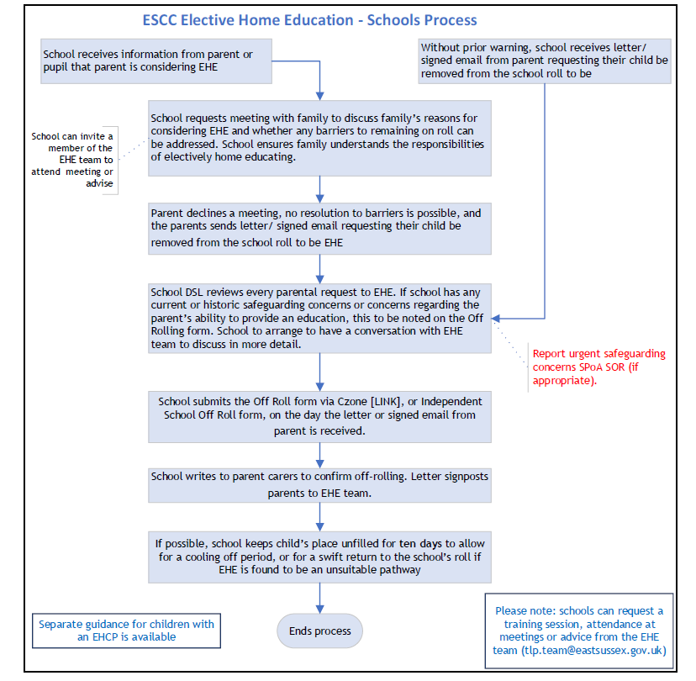
https://czone.eastsussex.gov.uk/admissions/ehe/off-roll

Local Offer: East Sussex Local Offer
East Sussex County Council
Flexible Schooling Policy

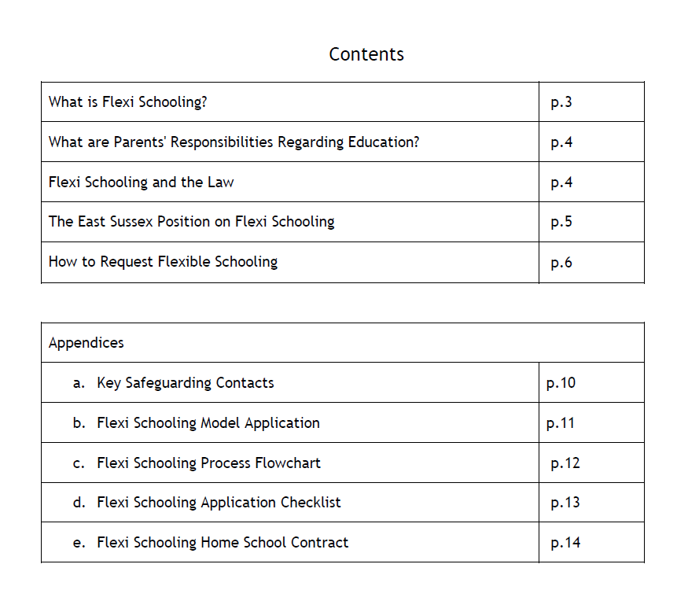
Flexi-schooling Guidance
This guidance is supplementary to, and should be read in conjunction with, the DfE Guidance, Elective home education: departmental guidance for local authorities (publishing.service.gov.uk). All decisions about Flexi-schooling must be made with reference to the DfE guidance which outlines statutory responsibilities. This document is not designed to replace the DfE Guidance but should be used as a series of checklists to ensure that the correct processes and procedures are followed.
This guidance is intended to be of assistance to all parties involved when making decision around flexi-schooling requests.
The Attendance Support Team in the Team Around the School and Setting (TASS) should be the first point of contact for any queries that Headteachers, governors, parents, pupils, or others may have regarding flexi-schooling.
What is flexi-schooling?
Flexi-schooling is where a child spends part of the week attending school, and some of the week educated at home or at an off-school site. This arrangement needs a formal request from parents and must have approval from the school. In such arrangements the child will always remain on the school roll.
It is an individual arrangement made between the school and the parent. It is recognised by the DfE as a valid full-time education. There is no pre-determined model for the amounts of time given to either of the settings and individual arrangements vary widely.
Flexi-schooling is not the same as home schooling/Elective Home Education. Parent/ carers who request flexi-attendance are asking for a pattern of provision which will involve attendance at school, as well as times when the child will receive educational provision at home.
Flexi-schooling is also different from temporary part-time attendance arrangements which the school/parent/carer may seek to make. Such arrangements are monitored and reviewed with the intention that the child returns to full time attendance as soon as possible. Flexi-schooling is full time, although the provision may be split.
Page 4

What are parents’ responsibilities regarding education?
The responsibility to ensure that a child receives full-time education whilst he or she is of statutory school age lies with the parent. The Education Act 1996 states; “that the parent/carer of every child of compulsory school age shall cause him or her to receive efficient full-time education suitable to his or her age, ability and aptitude, and to any special educational needs he or she may have, either by regular attendance at school or otherwise.”
Some parents/carers may decide to provide a suitable education by educating their child at home, rather than seeking to enrol their child at a school. This is known as “Home Schooling” or “Elective Home Education” and is where the parent/carer takes full responsibility for the education of the child.
Parents/carers have a legal right for their child to be registered at a school or Elective Home Education. There is not the same right to flexi-schooling.
Flexi Schooling and the law
Parents are allowed in law to ask schools about possible arrangements for flexi-schooling. However, there is no parental entitlement to flexi-schooling. It is entirely at the discretion of the school’s headteacher and the decision to agree it, or not, rests with the headteacher. If a school decides not to agree such an arrangement, there is no formal appeal process, beyond the school’s complaint procedures.
In April 2019, the DfE issued updated guidance for Elective Home Education, alongside separate guidance for parents. The April 2019 guidance contains the following paragraphs in relation to flexi-schooling:
“Although most children educated at home have all the provision made at home, or alternatively partly at home and partly in other ways such as attendance at privately-run part-time tuition settings, it is not essential that this be so. Some children who are educated at home most of the time are also registered at school and attend school for part of the week – perhaps one day a week. The purpose of this is usually to ensure the provision in specific subjects is satisfactory, although it can also help in other ways such as socialisation. If a child is of compulsory school age he or she must, overall, be receiving fulltime education even if components of it are part-time’. (para10.7, DfE Guidance for LAs in relation to EHE)
‘Schools are not obliged to accept such arrangements if requested by parents. If they do, then time spent by children being educated at home should be authorised as absence in the usual way and marked in attendance registers accordingly. It is not appropriate to mark this time as ‘approved off-site activity’ as
Page 5

the school has no supervisory role in the child’s education at such times and also has no responsibility for the welfare of the child while he or she is at home” (para10.8, DfE Guidance for LAs in relation to EHE)
The East Sussex position on flexi-schooling
We are working hard across schools and settings to ensure that children attend every day. We believe that the educational, social, and emotional needs of young people are best met in most circumstances, through full time attendance at their school or college. A young person who attends every day - taught by professionals through a balanced curriculum, within a safe, stimulating and socially supportive environment - is most likely to fulfil their potential and go onto become a well-rounded citizen, able to contribute meaningfully to society.
We do recognise, that some parents may exercise their statutory right to educate their child at home, and this can also be an effective and happy experience for the child that enables them to grow and thrive. Where parents do take up this option, we will support this decision but make all necessary checks to ensure that the child is receiving a safe, enriching educational and personal experience.
Parents also have the right to request that their child, whilst registered at school, only attends for part of the week in a model sometimes referred to as "flexi-schooling". It must be understood that schools are not obliged to accept such arrangements if requested by parents. Furthermore, any time spent by children being educated at home within such an arrangement will be recorded on school records as absence, albeit Authorised absence. During this absence, the school have no supervisory responsibility for the welfare of the child, and full responsibility sits with the parents.
At East Sussex, whilst recognising the right of parents to request such flexible attendance, we would not recommend it.
What should parents consider?
The implications of making partial educational provision at home are significant, both in terms of expertise and resources and in the commitment to make a shared provision work. Concerns are sometimes raised about friendships being affected when children flexi school and the possible impacts upon socialisation and peer group engagements need to be carefully considered.
The education provided at home and at school should together constitute full-time. Whilst there

Page 6

is no statutory curriculum to be followed at home, parents/carers will need to be mindful of the impact on the child's access to the school curriculum and the possible fragmentation of the learning experience. Parents/carers would need to discuss with the school the topics being covered and those being missed during flexi schooling periods. This would enable parents/carers to complement the schoolwork at home and cover missed topics. Flexi-schooling does not give an alternative means of opting out of an element of the school curriculum, or particular subjects for any reason.
If the child moves to a different school, there will be no guarantee that flexi schooling will be able to continue. This will be a decision for the Headteacher at the new school.
How to request flexi-schooling
If having carefully considered all factors a parent/carer wishes to make a request for flexi-schooling, they should contact the Headteacher of the child’s school and or prospective school if not yet attending the school.
Flexi-school arrangements will be subject to the same admissions process as other children and are counted in the same way as a child who attends full time for the purposes of infant class size regulations. A parent/carer will need to present a compelling case to the Headteacher that flexi-schooling is in the best interests of the child, for example by writing a proposal explaining the benefits for the child and practical examples of how the arrangement will work between the school and parent/carer. The Headteacher will be expected to review every request for flexi-schooling and respond to the parent with their decision. There is no requirement for the governing body to be involved in this decision and there is no right of appeal beyond the schools own complaints procedures.
What should Headteachers consider?
All requests must be considered by the Headteacher on their own merits. The Headteacher should always consider the best interests of the child; their educational progress and achievement; their safety, safeguarding and welfare; together with the likely impact on the discipline, morale, and organisation of the school.
The safeguarding of any child should always be of paramount importance in any decision. Any decisions should be taken with full cognisance of any existing safeguarding concerns. Where a child attends another setting on those days when not in school, it is incumbent on the parent to ensure the adequacy of the safeguarding arrangements in operation at this setting. The Headteacher should, however, still act in response to any concerns that may arise.
Page 7

When the curriculum is delivered through cross-curricular activities, arrangements made with the parent/carer would need to protect the cohesion of the child's experience. There may be resource implications; effective co-ordination will require time and, although there is no obligation to do so, the school may well decide that it will need to provide materials so that learning can keep pace with that of other children.
There is no opt-out for schools with regards to the National (Academy) Curriculum based on a flexi-schooling proposal. Although the child is not attending all school sessions, the school will still need to ensure that the child has appropriate access to the National (Academy) Curriculum. The child cannot be disapplied from statutory curriculum or assessment arrangements simply because flexible attendance has been agreed.
Children should be recorded as absent when not in school. The C code (authorised absence) should be used. Some schools have expressed concern that such absence may have a detrimental effect for the purpose of Ofsted inspection, but this is not the case (para10.8, DfE Guidance for LAs on Elective Home Education). In line with the DfE guidance on Elective Home Education issued in April 2019, on the days the child is being educated by the parent outside of school, the school must not use the B code as this would mean that the school is responsible for supervising the off-site education and will ensure the safety and welfare of the child when off site; C code would be the most appropriate code to use. If the child is unable to attend a home-based session because of illness the parent/carer should inform the school, and this should be reflected in the school’s register. It may be appropriate to schedule in periodic liaison between the teacher and the parent so that the topics being covered in school can be explained. The teacher may wish to provide additional resources, but this is not expected.
Arrangements for flexi-schooling may make both the identification of SEND and the ability to meet those needs more difficult to secure. Effective assessment would need to take place across both the school and home-schooling elements of the child's education and so could present logistical challenges. To ensure that flexi schooled children are able to have the same access as other children to the school based early identification of any special educational needs, the same principles of close collaboration between parents/carers, the school and any other professionals involved with the child should apply.
Where a child has an Education Health Care Plan (EHCP), the decision must be taken in conjunction with the Local Authority. Where flexi-schooling is agreed for a child with an EHCP, this should be recorded on the Plan and progress monitored through the usual annual review
Page 8

process. It is not necessary to wait for the EHCP amendments to be made before the agreed flexi school arrangement to commence. Since the child remains on the school roll, the school retains the responsibility for the child’s progress and for tracking that progress. The school receives full funding for flexi-schooled children, and they must be included in all census returns. The responsibility for the arrangement lies with the school and not the Local Authority and schools will need to work with parents to address any issues which arise.
Our expectation is that all Children in Care have access to their full educational entitlement, and therefore there should not be an occasion for a corporate parental request for flexi-schooling for a Child in Care unless this is based on the advice of health professionals involved with the child. This would then be regarded as a reduced timetable. If a child is on a reduced timetable, we expect this would be a short-term intervention to enable support to be put in place to enable a return to full time education. Headteachers will always seek advice/guidance from the Virtual school prior to any implementation of a reduced or flexible timetable.
Where a child attends a school for which they have an entitlement to transport free of charge, this entitlement will not be affected by the flexi-schooling arrangement. However, transport will only be provided at the standard school start/ end times on those days the child attends under the flexi-schooling arrangement.
Flexi-schooling agreements
In cases where flexi-schooling is agreed, it is recommended that the school has a written agreement with the parents/carers so that expectations and arrangements are clear for both parties. Such an agreement may include:
- The normal expected pattern of attendance at school.
- The rationale why flexi-schooling arrangement is in the best interests of the pupil.
- Procedures for flexibility around special events which fall outside the normal arrangement.
- How the register will be marked.
- That the school will follow up any unexpected or unexplained absence in the same way as it does for other children.
- Arrangements at times of assessment.
- Details of any perceived special educational needs and associated provision including how any high needs funding, if a child has an EHCP, will be deployed.
- Agreement that if the parent/carer chooses to employ other people to educate their child at home, they will be responsible for making sure that those whom they engage are
Page 9

- this decision.
- Agreement on who will meet the cost of exam entries. These are the responsibility of the parent, but the school may choose to support with some or all of the costs.
- Details of any special educational needs and associated provision.
- Arrangements for regular planning and review meetings between parent/carer and school to ensure the child achieves his/her potential and to promote good home/school relationships.
- Clarity about the circumstances under which and with what notice either party can withdraw from the arrangement.
- The arrangements for the resolution of any disputes (usual processes are for disputes to be resolved at the most informal level possible, but ultimately any complaints will need to be considered by the Headteacher first and then the Governing Body as set out under the school's complaints procedure).
- We have developed a sample contract and attendance agreement (appendix A).

Flexi-schooling for children with an Education, Health, and Care plan
Where a child has an Education Health and Care plan (EHCP) the decision to agree flexi-schooling must be taken in conjunction with the local authority (LA) SEND Team. Where flexi-schooling is agreed for a child with an EHCP this should be recorded on the EHCP, and progress monitored through the usual annual review process. The school receives full funding for flexi–schooled pupils and they must be included on all census returns.
The responsibility for the flexi-school arrangement lies with the school and not the LA. The school will need to work with parents to address any issues which arise.
Arrangements for recording flexi-schooling attendance
It is important to note that in the event of a flexi-schooling arrangement being agreed, any sessions where the pupil is receiving education at home will be recorded as 'authorised absences' within the school's register. This will have a detrimental impact on the overall absence levels of the school in question. The code which schools are required to enter into their register for any such sessions is the 'C' code which reflects that the pupil is absent due to 'other authorised circumstances' – in other words, the flexi-schooling arrangement has permitted the pupil to be absent from school.
Page 10

It is not appropriate for schools to mark the register as “approved off-site activity" for the time the pupil is being flexi-schooled as the school has no supervisory role in the child's education at such times and has no responsibility for the welfare of the child while he or she is at home.
Monitoring flexi-schooling
Neither the Local Authority nor the school have a statutory duty to monitor the quality of home education on a routine basis.
However, if it appears to the school that parents/carers are not providing a suitable education as agreed between the school and the parent/carer, the school may ask the parent/carer to take remedial action.
If the parent/carer declines to do so or the school is still concerned about the provision of education at home, the school may withdraw its agreement to the flexi-schooling arrangement. The child would then be required to return to school on a full-time basis whilst they remain registered, or the parent assumes responsibility for arranging their child’s education on a full-time basis (i.e. de-registration for the purposes of Elective Home Education). A School Attendance Order would not be appropriate as the child is on the roll of a school. If a child fails to return to full-time attendance the school leaves the absence unauthorised then they should discuss with the Attendance Support Team in the Team Around the School and Setting.

(Appendix A) Safeguarding Key contacts
- Local Authority Designated Officer (LADO): Consultation via the online portal here
- Referrals into Early Help and Social Care Single Point of Advice: 01323 464222 or Contacting the Single Point of Advice (SPoA) | East Sussex County Council
- Emergency Duty Service (after hours, weekends and public holidays): 01273 335906 or 01273 335905

DfE guidance
Elective home education: guide for parents (publishing.service.gov.uk)
Elective home education: departmental guidance for local authorities (publishing.service.gov.uk)
Page 11

(Appendix B) Sample Contract and Attendance Agreement
Flexi-schooling
Additional Information Form
To be filled in alongside School Enrolment form either by parents or during meetin
Child’s name |  | Name of parents/carers
Admissions form completed Yes / No
What are your reasons applying for flex-schooling?
Why do you think that it is in the best educational interests of your child?
How will you organise the learning of your child when absent for flexi-schooling?
Will you ensure that your child continues to follow the National Curriculum?
Explain how you will provide appropriate supervision of your child during the flexi-periods of learning at home.
Will you be able to provide a suitable workspace for your child to work?
Page 11

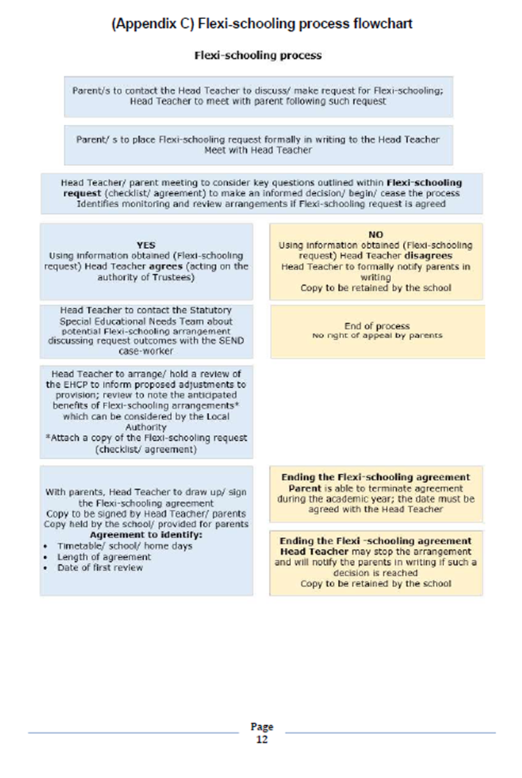
(Appendix D) Flexi-Schooling Checklist
Child’s name Parent/carer name
DOB Year Group | UPN
Date when request received
Have the parents fully explained the exact details of the flexi-schooling arrangements they have in mind & the reasons behind
their request. Are these reasons appropriate?
Has the request been confirmed by the parents in writing & request stored on the child’s file?
Is the school able to accommodate any concerns expressed by the parents within the parameters of full-time schooling?
Has the parents request been referred to the Statutory SEND Team?
Does it appear likely that the request, if approved, would impose an
additional workload on members of staff?
What is the nature of this additional workload?
Is the programme/ activity proposed by the parents educational and appropriate?
Have the parents produced any documentary evidence to support this? – e.g. – letters from other educational institutions, sporting academies etc?
Have the parents been made fully aware of their child’s current and anticipated level of educational attainment and the potential impact which their request for flexi-schooling might have on this?
Have the parents been made fully aware of any critical aspects of the curriculum/ assessment/ teaching in school which their child will miss if their child is flexi-schooled?
Should the school agree to the parents’ request, have
arrangements for monitoring and review been discussed and
agreed?
What timescales have been set?
Has an initial review date been agreed?
Have the parents been made aware that the school has the right to withdraw any agreement it might make to flexi-schooling arrangements if it considers that the original intentions and expectations are not being met?
Should the school be unable to agree to the parents’ request, have the reasons for this been fully explained and confirmed in writing and saved on the pupils’ file?
Have the parents been informed that their child will accrue absences (authorised for the periods of time they are flexi-schooled?)

DECISION
Original for student file, copy to parents

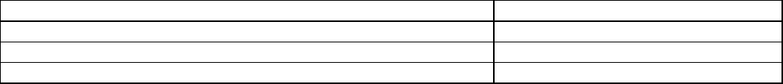
Approved/Not approved
Reason/comment
Signed (Headteacher)
Date

(Appendix E) Flexi-schooling Home School Agreement
During the period of the flexi-schooling arrangements;
- The pupil may attend special events which take place on the agreed non-school days/ times in consultation with the pastoral leader or other member of school staff.
- Parents retain the same access to records, reports and opportunities to meet with teachers as the other young people who attend school on a full-time basis e.g.: parents’ evenings, school reports.
Termination of the flexi-school agreement.
- The timetable will be subject to regular review meeting between parents and the Headteacher. This meeting will inform the decision as to whether the flexi-school agreement continues to be in the best interests of the child, and therefore is to continue.
- The parent may terminate the flexi-schooling agreement, at any point during the academic year. The date of return to full time education will be agreed with the Headteacher.
- The Headteacher may terminate the flexi-school agreement, if they believe that the arrangement is detrimental to the progress and or wellbeing of the child.
Child’s name |  |  |  |  | Parent/carer name
DOB |  |  | Year Group |  |  |  | UPN
Days /times of attendance of child |  |  |  |  | Monday  AM PM | Tuesday  AM PM |  | Wednesday  AM PM |  | Thursday  AM PM | Friday  AM PM
Date of the start of the flexi-school arrangement
Date of first formal review
We fully understand and agree to follow the contract and agree to fully engage with the
school to ensure that the best interests of the child are always met.
Headteacher Signature
Parent/Carer Signature(s)
Date
Original for student file, copy to parents
Page14

Reduced timetable guidance for schools, academies, and settings in East Sussex

Background and definition of a reduced timetable
This guidance does not refer to the ‘staggered’ introduction of reception-aged pupils.
All schools, academies, and free schools have a statutory duty to provide full time education for all pupils. This guidance sets out the East Sussex County Council position in relation to the practice in schools of reducing the amount of time that a pupil spends in an education setting.
Because pupils of compulsory school age are entitled to a full-time education, reduced or part-time timetables are only allowed in exceptional circumstances, where:
- There's a specific need for a pupil – for example, a medical condition prevents them from attending full-time education and a part-time timetable is part of a planned re-integration
- It's in the pupil's best interests
- It's on a temporary basis, stating when they're expected to return to school full time. It must not be a long-term solution
The DfE sets this out on page 25-26 of its guidance (Working together to improve school attendance (applies from 19 August 2024) (publishing.service.gov.uk) and page 11 of Summary of responsibilities where a mental health issue is affecting attendance (publishing.service.gov.uk) the guidance.
A reduced timetable should be for an ‘exceptional measure’. It is up to the school to determine what that would be but may include reasons such as:
- Medical reasons where a child has a serious medical condition
- As a result of a reintegration into school following a trauma
- A family bereavement

When is it not appropriate:
A part-time timetable should not be used to manage a pupil’s behaviour.
If behaviours are deemed ‘difficult or dangerous’, then this can often be an indication of an unmet need. In line with the SEND Code of Practice the school should assess needs, including involving other professionals as part of a graduated approach, whilst putting in place appropriate intervention and support and review progress.
For children presenting these behaviours, a risk assessment should be completed with predict, prevent, and progress which should be shared with all staff, embedded, reviewed, and clearly link to support programmes and interventions.

A part-time timetable must not be treated as a long-term solution. Any form of pastoral support programme (which in East Sussex should be recorded in an Additional Needs Plan) or other agreement must have a time limit by which point the pupil is expected to attend full-time or be provided with alternative provision.
A reduced timetable means that, by agreement with the pupil, parent or carer and school, the number of hours spent in education are reduced for a time limited period of no more than six weeks. Once a reduced timetable has been agreed, where no alternative provision is being provided by the school, the pupil should be marked as an authorised absence (C code) for the part of the day they are not in school.
Schools have a duty of care for all pupils who are on their school roll. The school must ensure that when a pupil is not expected to attend, there is a signed, written agreement with parents, or alternative education providers, about who is carrying out the duty of safeguarding for each session.
Where the pupil has a social worker, the school is expected to keep them informed and involved in the process.
If the pupil has an education health and care plan, the school should discuss the part-time timetable with the local authority so that any support package that is in place can be reviewed as swiftly as possible.
In agreeing to a part-time timetable, a school has agreed to a pupil being absent from school for part of the week or day and therefore must record the absence accordingly (normally using code C2).
This guidance is not intended to be applied to those pupils where a flexible learning programme has been put in place. Provided that the school has a mechanism in place for ensuring that the pupil is attending the alternative provision and the pupil’s total educational programme is full-time, this arrangement would not be considered as a reduced timetable.

Best Practice Guidance for reduced timetables
When considering placing a pupil on a reduced timetable, the school:
- Must be satisfied that a reduced timetable is an appropriate intervention given the needs of the pupil. There must be a clear and evidenced rationale for considering a reduced timetable as an intervention aimed at supporting the needs of the pupil and the maintenance of the education placement. A detailed assessment, recorded on an additional needs plan, must show the support required for all pupils on reduced timetables.

2. Must not pursue a reduced timetable without parental permission. This can be construed as an unofficial exclusion, which is unlawful, as the parent has not requested leave for their child, or the school could be regarded as preventing the pupil from accessing the curriculum.
3. Must have signed parental permission, evidenced on the pupil file prior to the commencement of a time limited reduced timetable. If the parent does not agree, the reduced timetable arrangements cannot be implemented. In these circumstances the school will have to consider alternative interventions.
4. Must complete a detailed action plan, agreed with the parents and the pupil, demonstrating a clear path of planned reintegration from part time to full time provision over a maximum of a six-week period. The school must ensure the pupil has an active involvement in the process of planning, reviewing, and evaluating the planned intervention. An example is shown in Appendix A.
5. Must not put in place a reduced timetable that exceeds a six-week period. If the pupil is still on a reduced timetable as the time limit approaches, a multi professional review should be held to organise full time education. A maximum of one further period of six weeks should only be agreed in exceptional circumstances, with parental agreement, and the plan revised to reflect why an extension was appropriate. The local authority has a duty to monitor the provision for all pupils who are not receiving full time education.
6. Ensure that where pupils have an Education, Health and Care Plan, the Local Authority must be involved to ensure the EHCP is reviewed and amended where appropriate. An annual review should be convened to make the proposal known. The Local Authority must agree to the reduced timetable intervention and a reduced timetable must not interfere with additional support given to a pupil due to his/her educational needs.
7. Must undertake a risk assessment of the pupil’s needs to assess the impact that a reduced timetable would have on the pupil. It is essential that the pupil’s welfare during any absence from school is considered. Risk assessments should follow the five steps identified by the Health and Safety Executive:
Step 1: Identify possible hazards
Step 2: Decide who may be harmed and how
Step 3: Evaluate the risks and decide on precaution
Step 4: Record your findings and implement them
Step 5: Regularly review your assessment and update if necessary

The risk assessment should include the safety and wellbeing of the pupil as well as the risk of the pupil engaging in criminal activity or substance misuse or being at risk of exploitation or radicalisation whilst not in receipt of education during the school day.
8. Must ensure that school attendance officers/staff keep a central record of all pupils on a reduced timetable. It is recommended that reduced timetable pupil group is set up in the school’s MIS system to enable timely tracking and monitoring.
Local Authority Officers should be given access to school documentation relating to pupils on reduced timetables upon request. Local Authority Officers are legally able to take extracts from school’s registers under the Education (Pupil Registration) (England) regulations 2006. The schools link Attendance Support Team SPOC, single point of contact, will also discuss the C2 coding when holding school Targeting Support Meetings (TSM).
All pupils should receive full time education hours consistent with their key stage:
- 21 hours at Key Stage 1
- 23.5 hours at Key Stage 2
- 24 hours at Key Stage 3
- 25 hours at Key Stage 4

It is illegal for schools to discriminate against pupils based on their SEN or disability, including those with social emotional and mental health difficulties, under the Equalities Act 2010.
Further guidance:
- SEND Code of Practice

- https://assets.publishing.service.gov.uk/media/66be0d92c32366481ca4918a/Suspensions_and_permanent_exclusions_guidance.pdf
Reduced Timetable Re-integration Plan

Name:  Year Group: | School:  Class/Tutor: | Meeting with parent / carers (Y/N): |  | Start date: Click or tap to enter a date. |  |  | End date: Click or tap to enter a date.
Objectives (what change do we want to see?) | Objective |  |  |  | Review 1 |  |  | Review 2
Objectives (what change do we want to see?) | Choose an item. |  |  |  | Choose an item. |  |  | Choose an item.
Objectives (what change do we want to see?) | Choose an item. |  |  |  | Choose an item. |  |  | Choose an item.
Objectives (what change do we want to see?) | Choose an item. |  |  |  | Choose an item. |  |  | Choose an item.
 | Plan  (Click or tap to enter a date.) |  | Review 1  (Click or tap to enter a date.) |  |  | Review 2  (Click or tap to enter a date.)
What will the school do?
e.g. Strategies, environmental adaptations, adult support, intervention, curriculum adaptation, reasonable adjustments etc.
What will parent/carers do?
e.g. Provide medical evidence where necessary; communicate/engage with relevant professionals; maintain contact with school link etc.

Reflective checklist
  - Consideration of Reduced Timetables
The Education Division team within East Sussex County Council recommend the use of the reflective checklist and conversation with relevant staff, support services (if involved) and parents or carers before a student is placed on a reduced timetable. This process enables the schools to reflect on the information they have and whether a reduced timetable is appropriate for that student.
It is very important to ensure that the safeguarding implications are robustly considered for children, particularly deemed vulnerable to exploitation or open to Social Care or the Youth Justice Service.
The flowchart in Appendix 1 shows the stages following the reflective conversation.
The following 9 questions to be completed each time the school is considering a reduced timetable for a student.
1. What stages of supportive interventions would you expect to have been completed before this student is considered for a reduced timetable?

2. Have all stages been completed in this case?
☐ Yes ☐No
If no, those stages must be completed before reduced timetable is agreed. Continue with the reflective conversation questions.
If yes, what did the review of these stages tell you about what the behaviours or non-attendance are communicating, and any unmet or unidentified special educational needs or disabilities for this student?

3. Have you obtained an up-to-date student voice?
☐ Yes ☐No
If no, this must be completed and analysed before a reduced timetable is agreed. Continue with the reflective conversation questions.
If yes, what did this tell you about what the behaviours or non-attendance are communicating and how best to support this student?

4. Have you obtained an up-to-date parent/carer voice?
☐ Yes ☐No
If no, this must be completed and analysed before a reduced timetable is agreed. Continue with the reflective conversation questions.
If yes, what did this tell you about what the behaviours/non-attendance are communicating and how best to support this student?

5. Have you obtained teacher voice from key members of staff?
☐ Yes ☐No
If no, this must be completed and analysed before a reduced timetable is agreed. Continue with the reflective conversation questions.
If yes, what did this tell you about what the behaviours or non-attendance are communicating and how best to support this student?

6. What is a reduced timetable seeking to achieve and why will it be successful?

7. What unintended consequences may there be if the timetable is reduced for this student? E.g. impact on social groups, impact on self-esteem and confidence, pressures on the family etc.

8. What tools have been used to resolve the issues leading to the consideration of a reduced timetable?
☐ Therapeutic Thinking (Anxiety Mapping, Therapeutic Tree)
☐ Supportive parent/carer meetings
☐ Support recorded on Assess Plan Do Review sheet or Additional Needs Plan
☐ Mentor/trusted adult
☐ Personalised timetable (e.g. ragged, creative curriculum)
☐ Reasonable adjustments to school policies
☐ Access to alternative provisions

9. Is the reduced timetable agreed to be appropriate?
☐ Yes ☐No
Supported reflective conversation undertaken between ……. on (date)

Appendix 1
Supported reflection conversation.
Has a reduced timetable been agreed?
If no:
School aware of support available through LA education support services
If yes:
Is additional support required to ensure the student will be able to successfully access full time education after 6 months?
If no:
School follows ESCC reduced timetable guidance including involving the parent or carer and student in decision-making and holding regular reviews. (see below)
If yes:
Is an LA supporting the student?
If no:
School follows ESCC reduced timetable guidance including involving the parent or carer and student in decision-making and holding regular reviews. (see below)
If yes:
School discusses any further support needs with the LA’s Education Division representatives allocated to their school.
Identify and agree the most appropriate support from:
Resources for the key members of teaching and support staff to reflect on their practice in relation to nurturing a positive relationship with the student and how they can positively and negatively impact on the student’s wellbeing and confidence
Resources that support classroom practice:
Universally Available Provision document (section for teachers and pastoral staff)
- SEN Matrix https://czone.eastsussex.gov.uk/send/sen-matrix
- Universal support PowerPoints and videos from CLASS CLASS | Czone (eastsussex.gov.uk)
- Anxiety Toolkit https://czone.eastsussex.gov.uk/media/chrmavnf/anxiety-toolkit.docx
- EBSA Toolkit https://czone.eastsussex.gov.uk/health-wellbeing/mhew/emotionally-based-school-avoidance-ebsa-toolkit/ebsa-toolkit/summary-toolkit
- Inclusion and SEND - Czone
- Health, safety, wellbeing - Czone
Off-Rolling
A pupil’s name can only be deleted from the admission register for a reason set out in regulation 9 of the School Attendance (Pupil Registration) (England) Regulations 2024. When any of the situations set out in regulation 9 occurs, the pupil’s name must be deleted.

A pupil’s name must not be removed for any other reason and doing so could constitute off-rolling. In accordance with regulation 13(4) to (6), a school must make a return to the local authority when a pupil’s name is deleted from the admission register (a Deletion Return). This does not apply where the pupil’s name is deleted at or after the end of the last term of the school year when they are in the school’s most senior class (for example, pupils who leave primary school at the end of Year 6), unless the local authority has requested such information.

Where a school notifies the local authority that a pupil’s name is deleted from the admission register, as set out in regulation 13(4), the school must provide the local authority with the following information about the pupil from the admission register: The off-rolling form found on Off-rolling notification | Czone (eastsussex.gov.uk) this should be submitted, as it contains all the information that is required to enable off-rolling to take place.

The reason set out in regulation 9(1) or (3) under which the pupil’s name has been deleted from the admission register. A school cannot retrospectively delete a pupil’s name from the admission register or attendance register. The admission register and attendance register must be an accurate record of who is a registered pupil and their attendance at any given time. A pupil’s attendance must be recorded up until the date that the pupil’s name is deleted from the admission register. Deleting the name of a pupil of compulsory school age.

The only reasons why a pupil’s name shall be deleted are:

Ground A - The pupil has been registered at another school Relevant regulation 9(1)(a) 223. Where a pupil has been registered at another school, unless:
• a school attendance order naming the school is in force in relation to the pupil (see further information below),
• the pupil is a mobile child and the school is their main school (see further information below),
• the school has agreed with a person with control of the pupil’s attendance at the other school that the pupil should be registered at more than one school (see further information on dual registration below), or
• the school itself has control of the pupil’s attendance at the other school and has decided that the pupil should be registered at more than one school (see further information on dual registration below).
Transfer between schools. Where a pupil is transferring to another school, the original school must delete the pupil’s name from the admission register as soon as they are entered on the admission register of the new school. The new school must enter the pupil’s name on the admission register on the first day that it has agreed or been told the pupil will attend the school as explained under Expected First Day of Attendance.

For example, if a pupil leaves School A on 28 March and their expected first day of attendance at School B is 29 March, they would be added to the admission register of School B and deleted from that of School A on 29 March. School A will:
• record the pupil’s attendance and absence up to and including 28 March,
• delete the pupil’s name from the admission register on 29 March, and • transfer the appropriate pupil information via the S2S system.
School B will:
• enter the pupil’s name on the admission register on 29 March, • record the pupil’s attendance and absence from 29 March,
• follow up any unexpected absence on or after the 29 March, and
• request the transfer of the pupil information.
There are a small number of exceptions, these are:
School attendance order. If a school attendance order is in place for the pupil, and the name of the school has been replaced by the relevant local authority with that of another school, their name must be deleted from the admission register under the reason for deletion at ground D (regulation 9(1)(d)). If the school attendance order has not been amended and still names the school, under ground A the pupil’s name must not be deleted even if they have been registered at another school as well.

Mobile child. Where a child of compulsory school age has no fixed abode and their parent(s) is engaged in a trade or business of such a nature as to require them to travel from place to place, the child can temporarily attend another school without the need for their main school to remove their name. Main school in this context means the school that, during the last 18 months, the child has attended during periods when their parent was not travelling in the course of their trade or business, or, if there is more than one school that fits that description, the school that most recently fulfils those criteria.

Dual registration. In circumstances where it has been agreed between the school and a person with control of the pupil’s attendance that the pupil will be registered at more than one school, the pupil’s name will remain on the admission register. This is also the case where it has been decided by the school if it has control of the pupil’s attendance at the other school. The main examples of dual registration are pupils who are attending another school on a temporary basis, such as a pupil referral unit, a hospital school or a special school.

Ground B - The pupil has not continued at the school following completion of nursery education Relevant regulation 9(1)(b).

Where a pupil has been admitted to the school to receive nursery education and on completing nursery does not continue into reception (or more senior class).

Ground C – The pupil is also registered at one or more other schools and the other schools have agreed the deletion Relevant regulation 9(1)(c) 233. Where a pupil is registered at one or more other schools, and:
• the school does not have reasonable grounds to believe that the pupil will attend the school again,
• each school where the pupil is registered has given consent to the deletion,
• there is no school attendance order naming the school in force in relation to the pupil (see further information below), and
• the pupil is not a mobile child, or if they are, the school is not their main school (see further information below).

School attendance order. If a school attendance order is in place for the pupil, and the name of the school has been replaced by the relevant local authority with that of another school, their name must be deleted from the admission register under the reason for deletion at ground D (regulation 9(1)(d)).

If the school attendance order has not been amended and still names the school, the pupil’s name must not be deleted under ground C even if the other criteria are satisfied.

Mobile child. Where a child of compulsory school age has no fixed abode and their parent(s) is engaged in a trade or business of such a nature as to require them to travel from place to place, the child can temporarily attend another school without the need for their main school to remove their name. Main school in this context means the school that, during the last 18 months, the child has attended during periods when their parent was not travelling in the course of their trade or business, or, if there is more than one school that fits that description, the school that most recently fulfils those criteria.

Ground D - The pupil has a school attendance order which has been changed to name another school Relevant regulation 9(1)(d) 238. Where the pupil is the subject of a school attendance order that previously named the school, but another school has now been named on that order instead.

Ground E - The pupil had a school attendance order which has been revoked Relevant regulation 9(1)(e) 239. Where the pupil was the subject of a school attendance order naming the school, but the order is revoked because the local authority that made the order is satisfied that arrangements have been made for the child to receive suitable full-time education for their age, ability and aptitude and special educational needs somewhere other than at a school.

Ground F - The parent of a pupil has notified the school in writing that the pupil will be leaving the school to be educated otherwise than at a school Relevant regulation 9(1)(f)

Where the pupil’s parent has informed the school in writing that the pupil will no longer attend the school after a certain day and will receive education otherwise than at a school and that day has passed, and there is no school attendance order naming the school in force in relation to the pupil. School Attendance Order. If a school attendance order has been revoked because the local authority that made the order is satisfied that arrangements have been made for the child to receive suitable full-time education for their age, ability and aptitude somewhere other than at a school, the pupil’s name must be deleted from the admission register under the reason for deletion at regulation 9(1)(e).

Ground G - The pupil no longer normally lives a reasonable distance from the school Relevant regulation 9(1)(g) 242. Where a pupil no longer normally lives a reasonable distance from the school, the school does not have reasonable grounds to believe the pupil will attend the school again, and the pupil is not a boarder at the school.

In circumstances where parents are moving away and withdrawing their child but are unable to say how their child will continue with their education, for example, the family are relocating but have not been able to secure a place at a new school in advance, once the pupil has completed their final day at school and moved out of the area, the school must delete the pupil’s name from the admission register and the pupil’s information should then be transferred to the Lost Pupil Database via the S2S system, and submit a form to CME Child missing education (CME) | Czone (eastsussex.gov.uk)

Reasonable distance. DfE does not define reasonable distance because each case depends on the family situation and the geography of the area for example, the parent's ability to get the child to the school, a safe walking route or the accessibility of local transportation. Temporary or occasional absence Relevant regulation 9(5)(a). Whether a pupil normally lives a reasonable distance from the school is not affected by a temporary or occasional absence. A judgement should be made in an individual case as to whether an absence is temporary or occasional, but a prolonged absence is not generally considered as temporary.

Ground H - The pupil has not returned following a leave of absence Relevant regulation 9(1)(h). Where a pupil has been granted a leave of absence and:
• the pupil has not attended school within the ten school days immediately after the end of the period that the leave was granted for,
• the school does not have reasonable grounds to believe that the pupil is unable to attend because of sickness or an unavoidable cause, and
• the school and the local authority have jointly made reasonable efforts to find out the pupil’s location and circumstances, but: they have not succeeded, or they have succeeded but they agree that there are no reasonable grounds to believe that the pupil will attend the school again, taking into account any reasonable steps that could be taken (either jointly or separately) to secure the pupil’s attendance.

Ground I - The pupil has been continually absent from school for 20 school days Relevant regulation 9(1)(i) 252. Where a pupil has been continuously absent from the school for a period of 20 school days or more and:
• at no point during that period did any of the circumstances in regulation 10(3) Table 2 or 10(4) Table 3 other than the ones for codes G, N, or O apply.
• the school does not have reasonable grounds to believe that the pupil is unable to attend because of sickness or an unavoidable cause, and
• the school and the local authority have jointly made reasonable efforts to find out the pupil’s location and circumstances,
but: they have not succeeded, or they have succeeded but they agree that there are no reasonable grounds to believe that the pupil will attend the school again, taking into account any reasonable steps they could take (either jointly or separately) to secure the pupil’s attendance. Please note that all reasonable steps will include legal action for non-attendance.

Off-rolling notification | Czone (eastsussex.gov.uk)

Working together to improve school attendance (applies from 19 August 2024) (publishing.service.gov.uk)

Summary of Table of responsibilities

The full table can be found Summary table of responsibilities for school attendance (applies from 19 August 2024) (publishing.service.gov.uk)

This outlines the responsibilities of parent/carers, schools, academies trusts and local authorities, for all pupils, pupils at risk of becoming persistently absent, persistently absent pupils, severely absent pupils, support for cohorts of pupils with lower attendance than their peers, support for pupils with medical conditions or SEND with poor attendance, support for pupils with a social worker, looked after and previously looked after children, and monitoring.

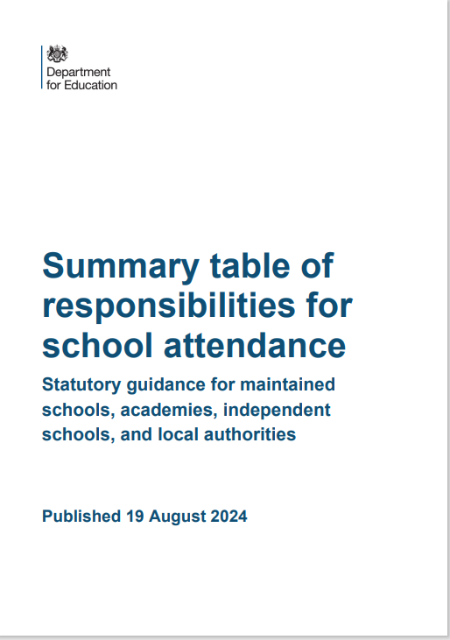

Anxiety and Emotional Based School Avoidance
Most anxiety serves a purpose and is beneficial to us, it provides motivation and keeps us from taking unrewarding risks. However, for an increasing minority of students, their anxiety causes interference in their daily lives and increases their risk of developing an anxiety disorder. Excessive worry or anxiety is the most prevalent type of wellbeing difficulty experienced by students and the number of children and young people who report feeling anxious is increasing.
Guidance has been created with the latest information and resources to help you normalise worry, recognise the signs of unhealthy worry, identify anxiety and access the support available. This guidance is for anyone working in education, to support staff when working with students who worry or are anxious.
This can be found on Anxiety | Czone (eastsussex.gov.uk). Support is also available from our Mental Health and Emotional wellbeing team through MHEW support teams | Czone (eastsussex.gov.uk), and a directory of services is available Mental Health - East Sussex 1Space.
The Department of Education has a paper to support you when Mental health issues are affecting a pupil's attendance: guidance for schools - GOV.UK (www.gov.uk)
Emotionally Based School Avoidance (EBSA) means some young people have trouble going to school because of emotional issues. It’s sometimes called Emotionally Based Non-Attendance (EBNA), especially for older students. In East Sussex, we use EBSA to describe children and young people who can’t attend school, not just those who choose not to.
EBSA doesn’t just mean missing school. It can also mean avoiding certain classes, places, or people.
EBSA is different for everyone, so there’s no single fix. But spotting the signs early and getting help can help young people manage changes, stay in school, and work towards their goals.
EBSA can present differently across individuals, but can include one, or a combination of, the following: fear and anxiety (including physical symptoms), misery, complaints of feeling ill without obvious cause, reluctance to leave home, tantrums, and/or oppositional behaviour.
A toolkit has been created for you to access and use to help identify EBSA or pupils at risk of EBSA, parent and carer information, and resources to support you. This is available through Emotionally based school avoidance (EBSA) toolkit | Czone (eastsussex.gov.uk).
A mentally healthy school or college is one that adopts a whole school/college approach to mental health and wellbeing. This brings the whole school/college together. Whole school approach (WSA) | Czone (eastsussex.gov.uk), Healthy schools | East Sussex County Council Microsites

Behaviour and Therapeutic Thinking
All behaviour is communication should be a key message within our schools. We should not forget this and should apply it to everyone in our school community. Understanding that behaviour is a form of communication can help teachers and staff reframe what they're seeing and not take student behaviour personally.
Therapeutic Thinking is an approach to behaviour which:
- supports staff to create clear behaviour policies
- focuses on to how to support all pupils’ emotional wellbeing and mental health
- helps to understand children’s behaviour and respond in an inclusive way that promotes change
The approach is school-led. It is based on training and information built on best practice, policy and plans.
The aim is for schools, and the services that support them, to base their inclusive practice on Therapeutic Thinking principles. Therapeutic Thinking | Czone (eastsussex.gov.uk)
The Inclusion helpline is available for advice and guidance, and mainstream schools and academies also have a link inclusion advisor. Contact can be made on the phone: 01273 481 967 (open Monday to Friday 8.30am to 4.30pm) Behaviour and inclusion | Czone (eastsussex.gov.uk).
For the vast majority of pupils, suspensions and permanent exclusions may not be necessary, as other strategies can manage their behaviour. If these approaches towards behaviour management have been exhausted, then suspensions and permanent exclusions will sometimes be necessary as a last resort. This is to ensure that other pupils and teaching staff can work in safety and are respected.
Suspensions and exclusions must be recorded on the attendance register using code E, East Sussex guidance is available Behaviour and inclusion | Czone (eastsussex.gov.uk), and the National Guidance Suspension and permanent exclusion guidance (publishing.service.gov.uk).
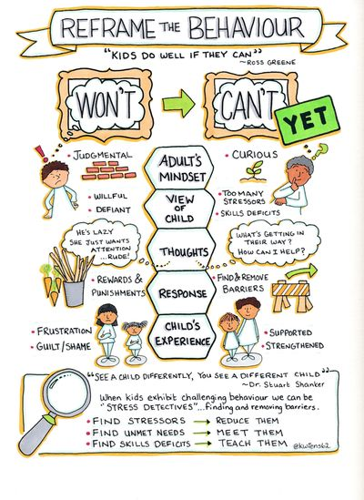
Services available to schools and settings

Local Authority | TASS Attendance Support Team Menu of Support
Statutory Duties | - Rigorously track local attendance data  - Legal Interventions and Children Missing Education  - Targeting Support Meetings  - Multi-Disciplinary support and approach  - Communication and Advice  - Monitor and improve the attendance of children with a social worker through their Virtual School
Core Support | - Monthly data reporting to schools and analysis of SEND and Disadvantaged cohorts  - Daily Attendance Advice Line available to schools and support services  - Named Single Point of Contact (SPOC) available to all schools for direct contact and support  - A minimum of three Attendance Forums a year to be held in geographical areas for all settings  - Training webinars on Attendance Matters  - Multi Agency Children Absent from Education Panel: 79%-51%  - TASS Attendance Newsletters  - AST SPOC available to attend to provide advice and guidance support at CIN/CP/YJS core group meetings, panel meetings and case conferences
Traded Offer | Traded offer options could include:  - Support at informal and formal attendance panels  - Cohort group work  - Home Visits  - Individual mentoring support  - School bespoke training: attendance policies, short term action planning, data analysis etc.  - Notice to Improve – intervention group work  - Training for new attendance staff and leads.  - Transition work  - Writing support plans  - Parental support and engagement/ group work by STOP trained practitioners  OR  - Bespoke work to meet emerging or identified needs

Traded support needs to be discussed with your school SPOC, once agreed you will need to make a request through the East Sussex | Services 2 Schools Webshop to purchase the appropriate amount of units. A unit is charged at £70 per hour for secondary schools and £65 for primary schools.


road
The DfE recommend
Successfully treating the root causes of absence and removing barriers to attendance, at home, in school or more broadly requires schools and local partners to work collaboratively in partnership with, not against families. All partners should work together to:

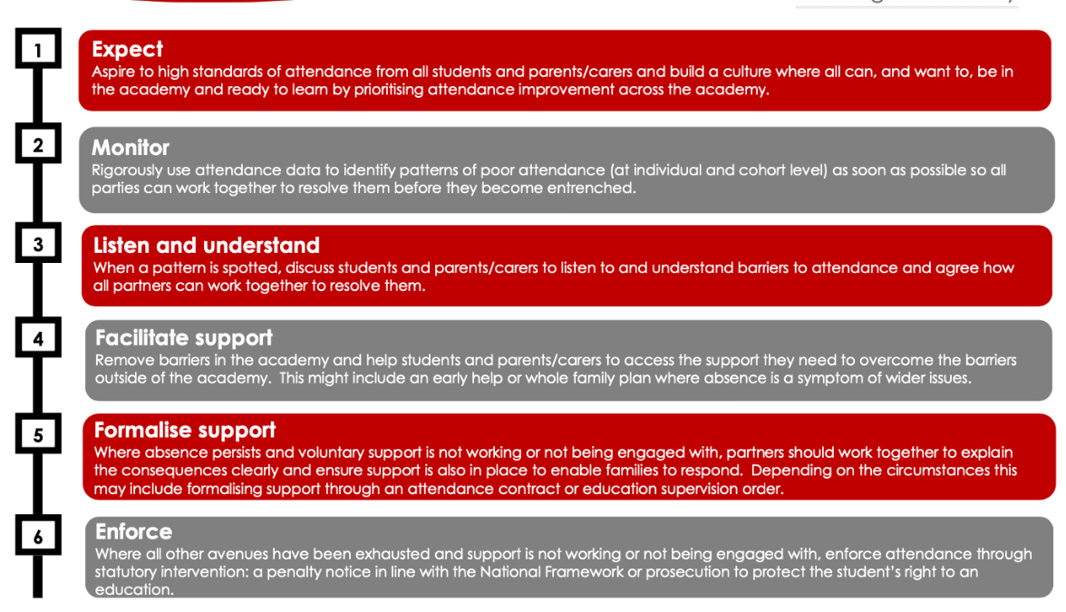

Working together to improve school attendance (applies from 19 August 2024) (publishing.service.gov.uk)
Supporting School Attendance Reflection and Planning Tool – Whole School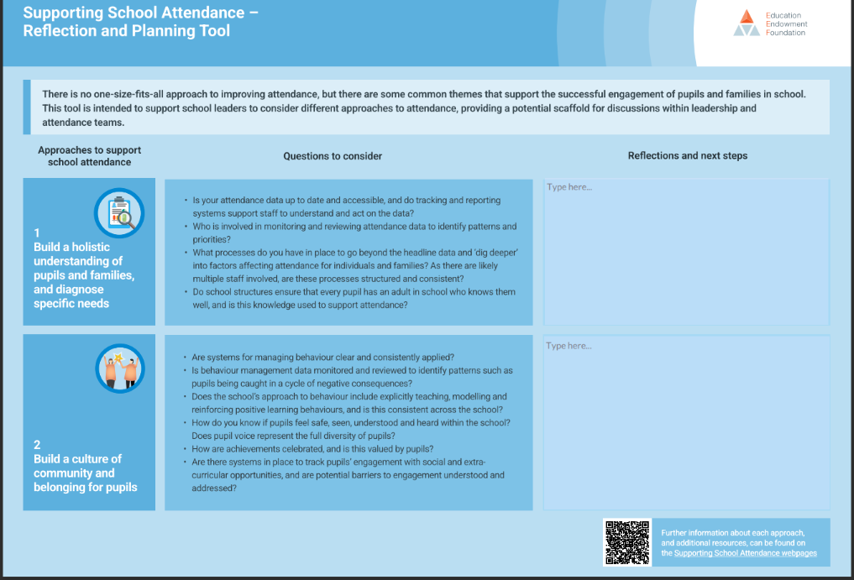


dutyline

DfE School Attendance Codes

It is a legal requirement for schools to have an Admissions and an Attendance Register. The The School Attendance (Pupil Registration) (England) Regulations 2024 (legislation.gov.uk), The Education Act 1996, and the Working together to improve school attendance (applies from 19 August 2024) (publishing.service.gov.uk) are the Statutory Instruments that apply.

The codes are outlined in these documents and are applicable throughout England, this is to ensure consistency and accuracy across all settings.

The DfE state that it is a criminal offence to misuse theses codes.

School Attendance Codes

Code | Description | Statistical Meaning | Physical Meaning | Present /Absent | When to use
/ | Present (AM) | Present | In for whole session | Present | Attended for the whole session - morning
\ | Present (PM) | Present | In for whole session | Present | Attended for the whole session - afternoon
B | Educated Off Site | Approved Educational Activity | Out for whole session | Present | Attending an off-site educational activity that has been approved by the school and supervised by someone authorised by the school. For pupils of compulsory school age, schools must also record the nature of the activity, attending courses at college. Attending an unregistered alternative provision arranged or agreed by the school. The pupil must physically be present at a setting.  This code must not be used for any unsupervised educational activity i.e., when a pupil is at home doing some schoolwork, completing work through an online platform such as google classroom, or Academy 21.
C | Authorised circumstances | Approved Absence | Out for whole session | Absent | Only exceptional circumstances warrant granting a leave of absence. Schools must consider each application for a leave of absence individually taking into account the specific facts and circumstances and relevant background context behind each request. A leave of absence is granted entirely at the headteacher’s discretion. that performance. If a pupil is subject to a temporary part-time timetable. A pupil is pregnant
C1 | Leave of absence for the purpose of participating in a regulated performance or undertaking regulated employment abroad | Approved Absence | Out for whole session | Absent | Where the local authority have granted a licence for the pupil to take part in a performance regulated by section 37(2) of the Children and Young Persons Act 1963.  Or where a pupil does not need a licence for such a performance because an exception applies under section 37(3) of the Children and Young Persons Act 1963, including where a Body of Persons Approval (BOPA) covering the pupil has been issued by the local authority in whose area the performance will take place or the Secretary of State.  Or where a Justice of the Peace has given the pupil a licence to go abroad for a performance or other regulated purpose under section 25(2) of the Children and Young Persons Act 1933.
C2 | Leave of absence for a compulsory school age pupil subject to a part-time timetable | Approved Absence | Out for whole session | Absent | When it is necessary to temporarily reduce the timetable of a pupil of compulsory school age to part-time, if the school and a parent who the pupil normally lives with have agreed that, exceptionally, the pupil should temporarily be educated only part-time and have agreed the times and dates when the pupil will, during the period of temporary part-time education, be expected to attend the school.  Where a pupil is receiving a full-time education, but only part-time at the school in question (e.g. dual registration, part-time unregistered alternative provision or flexi-schooling) this code must not be used and the appropriate code for why the pupil is not in school for that session should be used.
D | Dual Registration | Approved Educational Activity | Out for whole session | Discounted | This code is used to indicate that the pupil was not expected to attend the school in question because they were scheduled to attend the other school at which they are registered. The main examples of dual registration are pupils who are attending a pupil referral unit, a hospital school or a special school on a temporary basis.  Each school should only record the pupil’s attendance and absence for those sessions that the pupil is scheduled to attend their school. Schools should ensure that they have in place arrangements whereby all unexpected and unexplained absence are promptly followed up.
E | Exclusion / Suspension | Approved Absence | Out for whole session | Absent | The pupil is suspended from school or permanently excluded from school.  When a pupil of compulsory school age is suspended or permanently excluded on disciplinary grounds, an alternative provision must be arranged from the sixth consecutive school day of any suspension or permanent exclusion.  Both suspensions and permanent exclusions are recorded with E, but you should ensure that a permeant exclusion is input as such on your schools management information system, with the GDC date, which will autofill the appropriate attendance code.
G | Unauthorised Holiday | Unapproved absence | Out for whole session | Absent | Where the school has not granted a leave of absence for the purpose of a holiday, but the parents still take the child out of school, or the child is kept away longer that the period of leave granted. A school cannot grant a leave of absence retrospectively. If the parent did not apply in advance, leave of absence should not (and from certain types of school cannot) be granted.
H  THE USE OF THE CODE H HAS BEEN WITHDRAWN BY THE DfE FROM 19TH AUGUST 2024 | Authorised Holiday | Approved Absence | Out for whole session | Absent | An application for leave of absence should (and from certain schools must) not be granted unless it is made in advance by a parent the pupil normally lives with and the school is satisfied that there are exceptional circumstances based on the individual facts and circumstance of the case which justify the leave. Where a leave of absence is granted, the school will determine the number of days a pupil can be absent from school. A leave of absence is granted entirely at the headteacher’s discretion.
I | Illness | Approved Absence | Out for whole session | Absent | Schools must record absences as authorised where pupils cannot attend due to illness (both physical and mental health related). In the majority of cases a parent’s notification that their child is ill can be accepted without question or concern. Schools should not routinely request that parents provide medical evidence to support illness.
J1 | Interview | Approved Absence | Out for whole session | Absent | Attending an interview with prospective employers or another educational  establishment. Schools should be satisfied that the interview is linked to employment prospects, further education, or transfer to another school.
K | Attending education provision arranged by the local authority | Approved Educational Activity | Out for whole session | Present | When a pupil is attending a place, other than the school or any other school at which they are a registered pupil, for educational provision arranged by a local authority under section 19(1) of the Education Act 1996. For e.g. provision of education as outlined by the LA’s medical needs policy.  An example of when this can be appropriately used is when the pupil is accessing the Teaching and Learning provision.
L | Late (before register closes) | Present | Late for session | Present | Schools should actively discourage late arrival and be alert to patterns of late arrival. All schools are expected to set out in their attendance policy the length of time the register will be open, after which a pupil will be marked as absent. This should be the same for every session and depending on the structure of the school day not longer than either 30 minutes after the session begins, or the length of the form time or first lesson in which registration takes place.
M | Medical Appointment | Approved Absence | Out for whole session | Absent | Schools should encourage parents to make appointments out of school hours. Where this is not possible, they should get the school’s agreement in advance and the pupil should only be out of school for the minimum amount of time necessary for the appointment. If a pupil is present at registration but has a medical appointment during the session in question, no absence needs be recorded for that session.
N | No reason yet provided | Unapproved absence | Out for whole session | Absent | Where absence is recorded as unexplained in the attendance register, the  correct code should be inputted as soon as the reason is ascertained, but no more than 5 working days after the session. Code N should not therefore be left on the pupil’s attendance record indefinitely; if a reason for absence cannot be established after 5 working days, schools should amend the pupil’s record to Code O.
O | Unauthorised absence | Unapproved absence | Out for whole session | Absent | Where no reason for absence is established or the school is not satisfied that the reason given is an authorised absence.
P | Approved Sporting Activity | Approved Educational Activity | Out for whole session | Present | Taking part in a sporting activity that has been approved by the school.
Code Q | Unable to attend the school because of a lack of access arrangements | Approved Absence | Out for whole session | Absent | Is only used where a pupil is absent because the local authority has a legal duty to arrange home-to-school travel for the pupil and they have not done so, or because the pupil has no choice but to attend a school that does not qualify for such travel arrangements and is more than walking distance from where they live.
R | Religious Observance | Approved Absence | Out for whole session | Absent | A day exclusively set apart for religious observance’ as a day when the pupil’s parents would be expected by the religious body to which they belong to stay away from their employment in order to mark the occasion. If a religious body sets apart a single day for a religious observance and the parent applies for more than one day, the school may only record one day as authorised on this basis; the rest of the request would be a leave of absence, and this is granted at the school’s discretion as set out under Code C.
S | Study Leave (year 11) | Approved Absence | Out for whole session | Absent | Used sparingly and only granted to Year 11 pupils during public examinations. If schools do decide to grant study leave, provision must still be made available for those pupils who want to continue to come into school to revise.
T | Traveller Absence | Approved Absence | Out for whole session | Absent | Must only be used when the pupil’s parent(s) is travelling for occupational purposes and the school has granted a leave of absence following a request from the parent.  The pupil is No Fixed Abode – ‘No fixed abode’ means that someone either does not have a settled place where they can live full-time, or they have a place where they can live full-time but they spend substantial periods of time not living there. So a mobile child could be a child whose family travels all year round as part of their trade or business and has no permanent address at all, but it also includes a child who does have a fixed place to live (like a house) but does not live there for a substantial part of the year, if their parent is engaged in a trade or business that requires them to travel from place to place.  If the child is aged 6 or older, the parent must also prove that the child has attended school for at least 200 sessions in the preceding 12 months. This is in addition to the requirement to prove that the child has attended as regularly as the trade or business permits, which means that if the trade or business permits the child to attend for more than 200, they should do so.
U | Late (after register closes) | Unapproved absence | Out for whole session | Absent | Where a pupil has arrived late after the register has closed and the school is not satisfied that the reason for lateness is an authorised absence.
V | Educational Visit or Trip | Approved Educational Activity | Out for whole session | Present | Attendance at an organised visit or trip, including residential trips organised by  the school, or attendance at a supervised trip of a strictly educational nature arranged by an organisation approved by the school.
W | Work Experience | Approved Educational Activity | Out for whole session | Present | Work experience is for pupils in the final 2 years of compulsory school age.
X | Non compulsory school age absence | Attendance not required | Out for whole session | Discounted | Where a pupil not of compulsory school age is attending school part-time. For example, where parents have chosen for their 4 year-old child to attend parttime until later in the school year but not beyond the point at which the child reaches compulsory school age.
The DfE have introduced a set of sub-codes for Y, all of these are to be used for the outlined situation, when it is an emergency and an exceptional and unavoidable cause that affects the pupil and would be a statutory defence for school non-attendance in a Court of Law.
Y1 | Unable to attend due to transport normally provided not being available | Attendance not required | Out for whole session | Discounted | The pupil is unable to attend because the school is not within walking distance of their home and the transport to and from the school that is normally provided for the pupil by the school or local authority is not available.  Walking distance in relation to a child under the age of 8, means 2 miles, and for a child of 8 or above, means 3 miles. In each case measured by the nearest available route.
Y2 | Unable to attend due to widespread disruption to travel | Attendance not required | Out for whole session | Discounted | The pupil is unable to attend the school because of widespread disruption to travel caused by a local, national, or international emergency.
Y3 | Unable to part of the school site being unexpectedly closed | Attendance not required | Out for whole session | Discounted | Part of the school premises is unavoidably out of use and the pupil is one of those that the school considers cannot practicably be accommodated in those part of the premises that remain in use.
Y4 | Unable to attend due to the whole school site being unexpectedly closed | Attendance not required | Out for whole session | Discounted | Where a school was planned to be open for a session, but the school is closed unexpectedly (e.g. due to adverse weather), the attendance register is not taken as usual because there is no school session. Instead, every pupil listed in the admission register at the time must be marked with code Y4 to record the fact that the school is closed.
Y5 | Unable to attend as pupil is in criminal justice detention | Attendance not required | Out for whole session | Discounted | The pupil is unable to attend the school because they are:  • in police detention,  • remanded to youth detention, awaiting trial or sentencing, or  • detained under a sentence of detention. appropriate code.  If they are unable to attend because they are serving a community based (i.e. non-detained) part of a sentence of detention, referral order, or youth rehabilitation order that requires them to be absent during the school day.
Y6 | Unable to attend in accordance with public health guidance or law | Attendance not required | Out for whole session | Discounted | The pupil is well enough to attend (otherwise Code I would have been recorded) but there are Government rules or guidance to limit the spread of infection or disease which say they should not attend. Meaning, the pupil’s travel to or attendance at the school would be:  - contrary to any guidance relating to the incidence or transmission of infection or disease published by the Secretary of State for Health and Social Care (or the equivalent in Scotland, Wales or Northern Ireland), or  - prohibited by any legislation relating to the incidence or transmission of infection or disease.
Y7 | Unable to attend because of any other unavoidable cause | Attendance not required | Out for whole session | Discounted | This code should be used only where something in the nature of an emergency has prevented the pupil from attending the session in question.  The unavoidable cause must be something that affects the pupil, not the parent. The fact that a parent has done all they can to secure the attendance of the pupil at school does not, in itself, mean the pupil has been prevented by unavoidable cause.  Schools must also record the nature of the unavoidable cause (regulation 10(6)), examples are:  - Bail conditions (that prevent the pupil from attending the school or being present in the area where the school is situated)  - Court attendance (where the pupil is legally required to attend Court  - Housing crisis
Z | Not on roll | Attendance not required | Out for whole session | Discounted | To enable schools to set up registers in advance of pupils joining the school to ease administration burdens. Schools must enter a pupil’s name on the admission register from the first day that the school has agreed, or been notified, that the pupil will attend the school. If a pupil fails to attend on the agreed starting day, the school must establish the reason and record the pupil’s absence using the relevant absence code.
# | School closed to staff and pupils | Attendance not required | Out for whole session | Discounted | Whole school closures that are known and planned in advance such as: days between terms; half terms; occasional days (for example, bank holidays); weekends (where it is required by the management information system); up to 5 non-educational days; and use of school as a polling station.

Useful Links:

Support for the Travelling Community in East Sussex The Stopping Place | Home (eastsussex.gov.uk)

DfE Toolkit for schools: communicating with families to support attendance

DfE Annex A - Example letters and messages to parents and carers

Guidance for parents on school attendance: https://www.childrenscommissioner.gov.uk/back-into-school/resources-for-families/

Improving attendance: good practice for schools and multi-academy trusts - Case study - GOV.UK (www.gov.uk)

DfE School Attendance and absence codes FAQ

Texting parents: our key to success in tackling absence: https://teaching.blog.gov.uk/2022/02/04/texting-parents-our-key-to-success-in-tackling-absence/

Should I keep my child off school checklist poster (publishing.service.gov.uk)

Remote education – when can school children learn from home and how should they do it? – The Education Hub (blog.gov.uk)

Working Together to Improve School Attendance: DfE guidance overview for schools - YouTube
Education Services Directory




This document has been designed to support you, to give access to documents to help identify barriers and root causes of attendance concerns, early intervention is key, and building good habits for attendance can lead to improvements throughout academic life and beyond.

These tools are a guide and designed to be used by any staff at any level of attendance, as Rachel De Souza, Commissioner for Children points out attendance is everyone’s business. The Working Together to Improve School Attendance Paper states:

‘All schools have a continuing responsibility to proactively manage and improve attendance across their school community. As set out in chapter 1, attendance is the essential foundation to positive outcomes for all pupils including their safeguarding and welfare and should therefore be seen as everyone’s responsibility in school. That starts with the senior attendance champion on the school’s leadership team but includes all and everyone in every setting should be taking responsibility to support and improve attendance, and this will impact on the attainment and outcomes of every young person.’

Every setting has a designated Single Point of Contact (SPOC), and can access the attendance support line, if you are unsure of who the SPOC is for your setting please call the attendance support line, and they will be able to provide this information or pass on your details to them.

If you are concerned about a pupil’s attendance, raise this through your attendance champion in SLT, the DSL, or through your schools’ own procedures for non-attendance. Pupils that are not in school, are considered a safeguarding risk, and are not receiving the education that they are entitled to.

The current Department for Education campaign is moments matter, attendance counts, and previous campaigns such as miss school miss out all deliver the same message, and the vital role that educational settings have in the safeguarding, educating and life chances that a young person receives.

Make sure that you are curious around absences, are sensitive to the young person’s needs, and are willing to listen and support to make a difference to a young person’s attendance.



